The Trematodes

Cellular and Molecular Pathogenesis

Adult schistosomes usually do not cause signifi-
cant pathological damage in the host. It is believed
that the adult schistosome worm pair elicits remarkably
little in the way of host immunopathologic responses
as a consequence of unique antigen-masking proper-
ties. However, adult schistosomes living in the venous
circulation have the capacity to harbor enteric bacteria
affixed to their surface. This relationship can result in
the introduction of enteric bacteria, such as Salmo-
nella, directly into the bloodstream. As a result there is
a well-described association between chronic schisto-
somiasis and so-called enteric fevers from non-typhoi-
dal salmonellosis.22

Figure . . Schistosome egg in tissue of the small
intestine. Note intense granuloma.

Cercariae must infect within 8 hours after emerging
from its snail host; otherwise they exhaust their glyco-
gen reserves and die.
Infection in the human host is initiated when the
cercariae penetrate unbroken skin. With regards to S.
mansoni, this step requires about 0.5 hour, but occurs
much more rapidly with S. japonicum.20 Skin penetra-
tion is usually through a hair follicle, and is facilitated by
release of another set of proteases and eicasanoids.21
Cercariae shed their tails, and rapidly transform within
the dermal layer of skin into the schistosomula stage.
After approximately 2 days, the schistosomulae
migrate through the blood stream to the capillaries of
the lung, where they remain for another several days.
It is here that the immature worms acquire their ability
to incorporate host serum proteins onto their tegumen-
tal surface. This “camouflage” has the profound effect
of convincing the leukocytes that the worm is “self,”
enabling the parasite to live out a long, and prosperous
life inside its new host. In addition, the worm possesses
a β-2-microglobulin-like molecule that aids in confus-
ing immune defense cells, particularly macrophages,
in their attempt to recognize parasite antigens. Schis-
tosomulae migrate from the lungs via the blood stream
to the liver, where they mature to adult worms. Both
sexes produce chemotactic agents that are mutually
attractive, and eventually worms of opposite sex find
each other in the vastness of the parenchymal tissue.
They mate there, and migrate out into the mesenteric
circulation. Egg production begins shortly thereafter.
Other mammalian species, including baboons, rhesus
In contrast to adults, the eggs produced by the
worm pair result in profound immunopathologic
responses. This phenomenon accounts for almost all
of the pathology and clinical manifestations of schisto-
somiasis. For S. japonicum and S. mansoni, egg depo-
sition occurs in the circulation of the small intestine and
liver (Fig. 33.14) to produce intestinal and hepatic fibro-
sis, whereas S. haematobium egg deposition occurs
in the circulation of the bladder to produce fibrosis
leading to an obstructive uropathy. Heavy egg depo-

Figure .8. S. haematobium eggs in bladder wall.
Note terminal spine (arrow).
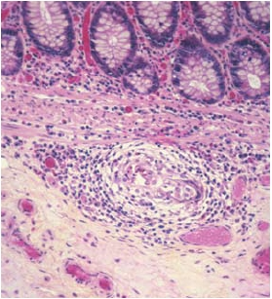

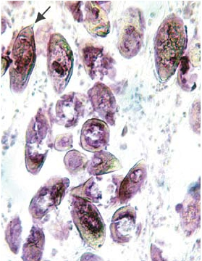

sition occurs predominantly in individuals with large
numbers of adult worms. Clinical illness caused by
schistosomiasis generally occurs only in people who
suffer from recurrent heavy worm burdens. Increasing
evidence suggests that a component of this phenom-
enon depends on host genetic factors.23 In this regard,
the same genes specific for susceptibility to Schisto-
soma mansoni have been identified in people living in
Africa and South America.24 In a study in the Sudan,
a specific gene locus was associated with advanced
liver disease confirming epidemiologic observations
of fibrosis occurring in families.25 Furthermore, immu-
nocompromised individuals with HIV shed fewer eggs
in stool exams than similar individuals without HIV.26
The soluble secretions from schistosome eggs, termed
soluble egg antigens (SEAs), trigger host inflamma-
tory and immune responses that result in granuloma
formation,27 and are T cell-dependent so as to include
prominent Th2 components.28 This Th2 bias can down-
regulate other host Th1 responses and result in altered
patterns of host susceptibility to other infectious patho-
gens, possibly including the human immunodeficiency

33. The Schistosomes

virus.29, 30 The pathogenesis of granuloma formation
also requires host-derived production of tumor necrosis
factor.31 The sizes of the granulomas vary with the age
of the infection. In newly acquired infections, granulo-
mas are large, causing displacement of normal tissue
with fibrotic, epitheloid reactions. Over time, eggs elicit
less and less volume of granulomatous tissue. This
reaction appears to be under the regulation of IL-12.32

Figure . 0. MiracidiumofS.mansoni.Phasecontrast.
Figure . . Miracidium of S. mansoni caught in the
act of hatching.
Granulomas form around eggs that collect in the
intestinal wall and result in fibrosis. Erosion of the sub-
mucosa and villous tissue also occurs, presumably by
the action of secreted proteolytic enzymes from the
eggs. In heavy infection, gastrointestinal hemorrhage
results from damage to the submucosa.
Eggs swept back into the liver block pre-sinusoi-
dal capillaries, and induce granulomas there, as well.
The presence of granulomas causes tissue fibrosis,
and eventually leads to obstruction of the hepatic vas-
culature. Fibrosis of most of the portal areas incorpo-
rating the blood vessels leads to pipe stem fibrosis
(Symmer’s Fibrosis) (Fig. 33.15), and, ultimately, to
portal hypertension. Clinically, this is manifest as hepa-
tosplenomegaly, the extent of which is dependent par-
tially on host major histocompatibility class II alleles.33
Development of collateral circulation follows, including
esophageal varices. Parenchymal liver cells remain
unaffected by granulomas, and, hence, liver function
remains normal.
Portal hypertension forces eggs to bypass the liver,
and many are carried to the spleen, which becomes
enlarged, further contributing to increased pressure in
portal circulation. Infection with S. japonicum results
in a greater number of granulomas and consequently
greater morbidity because this species produces, on
average, five to ten times more eggs than S. mansoni.
Collateral circulation may also wash eggs into the lung
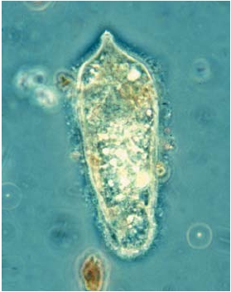

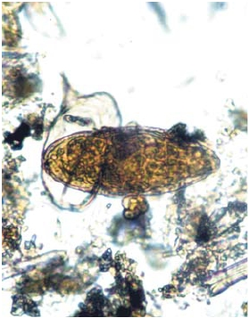

The Trematodes

brane disease.32
Penetration of the skin by cercariae is dependent
on the release of parasite-derived proteases and eica-
sanoids. The process of host entry typically causes
no major reaction, but repeated exposure can lead to
sensitization, and the development of a maculopapular
rash (Fig. 33.19), characterized by IgE or IgG antibod-
ies and an eosinophilic infiltrate. This is particularly true
of accidental skin penetration by avian or bovine schis-
tosomes. Many schistosomes specifically parasitic
for animals can cause aberrant infections in humans.
Avian schistosomes of the genera Austrobilharzia,
Trichobilharzia, and Ornithobilharzia, and other mam-
malian schistosomes (S. matthei and Schistosomatium
douthitti) are included in this group. The cercariae of
these species cause a hypersensitivity skin reaction
(cercarial dermatitis), known as “clam digger’s itch” or
“swimmer’s itch” (Fig. 33.20).
Cellular and humoral responses to both penetrat-
ing cercariae and migrating schistosomula are a critical

Figure . . Biomphalaria grabrata, the most
common intermediate snail host for S. mansoni.
capillary beds, occasionally leading to pulmonary fibro-
sis and consequent cor pulmonale.
Accumulation of S. haematobium eggs around the
bladder and ureters leads to granuloma formation and
fibrosis. In addition, calcification of dead eggs
in the bladder wall (Fig. 33.16) results in rigidity of the
bladder and subsequent increased pressure in the
ureters and kidneys. The bladder epithelium
develops pseudopol-yps (Fig. 33.17), which can
transform into squamouscell carcinoma
in untreated patients (Fig. 33.18).
In some patients with long-standing disease (in all
four types of schistosomiasis), deposition of immune
complexes in kidneys can lead to basement mem-

Figure . . Oncomelania nosophora, a snail inter-
mediate host for S. japonicum.

Figure . . Scanning electron micrograph of a
cercaria of S. mansoni. Photo D. Scharf.
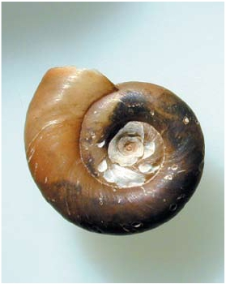

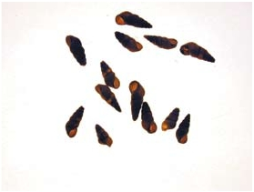

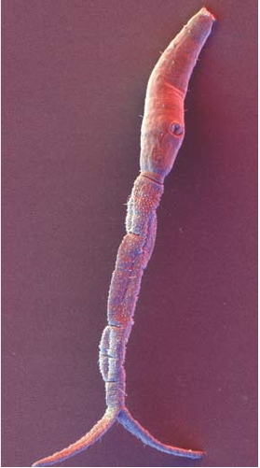

33. The Schistosomes

are attempting to bring a product to the field. Animal
protection studies have used the protein paramyo-
sin with good results in a mouse model although the
mechanism of protection is still under study.39 Studies
in the Philippines in a population with risk of exposure
to S. japonicum demonstrated that individuals with pre-
dominantly Th1 cellular immune responses appeared
resistant to initial infection.40, 41
Clinical Disease

As in other helminth infections, clinical disease
resulting from schistosomes usually occurs only in
heavily-infected individuals. The clinical manifesta-
tions of acute schistosomiasis occur predominantly in
S. japonicum and S. mansoni infections. This condition
is sometimes known as “Katayama fever”. The classi-
cal disease attributed to schistosomiasis occurs during
chronic infections. Chronic infection with S. haema-
tobium can also lead to squamous carcinoma of the
bladder.

Figure . . Granuloma in liver surrounding eggs
of S. mansoni. Note the lateral spine (arrow).

component of naturally-acquired immunity to human
schistosomiasis. This hypothesis derives from experi-
mental evidence showing that cercariae attenuated by
exposure to ionizing radiation (e.g., x-rays, gamma-
rays or ultraviolet light), can penetrate skin and migrate
through the tissues. In so doing they elicit protective
immune responses, including IL-13.35-37 These obser-
vations are the basis for an experimental vaccine in
non-human primates. However, the cercariae must
remain alive in order to secrete the antigens associated
with vaccine protection. In humans living in endemic
regions, this process may take years of exposure to
cercariae. Until then, young children have a particular
problem mounting an effective immune response to
invading schistosomulae. The mechanism by which
children during their early years of exposure to cer-
cariae and invading schistosomulae are susceptible
to the parasite but then become resistant over time
is unclear. One widely held hypothesis is that young
children respond initially to the parasite by producing
IgG4 blocking antibodies.38 It has been suggested that
blocking antibodies delay the development of protec-
tive IgE that is needed for the resistance to infection
that older people have in endemic areas.
Exploiting the current understanding of Th1 and
Th2 immune responses elicited by different candidate
antigens is the means by which vaccine researchers
Acute schistosomiasis
(Katayama fever)

The dramatic clinical manifestations of Katayama
fever occur most commonly in new immigrants who
experience intense levels of exposure to either S.

Figure . . Pipe stem fibrosis in liver due to heavy
infection with S. mansoni. Note normal liver tissue
next to fibrotic vessels.
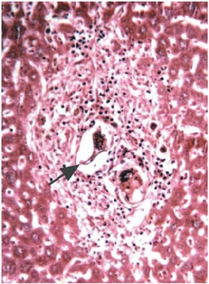

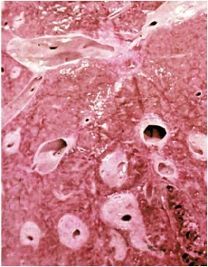

The Trematodes

Figure . 6. X-ray showing calcified dome of the
bladder due to chronic infection with S. haematobium.

Figure . . Histological section of bladder with pseu-
dopolyp due to chronic infection with S. haematobium.

japonicum or S. mansoni cercariae. The name reflects
the early descriptions of this syndrome in the Katayama
Valley of Japan. The symptoms are often dramatic and
appear approximately 4-8 weeks after initial exposure,
when adult worm pairs begin releasing their eggs in
the tissues. Some investigators believe that Katayama
fever resembles some of the manifestations of serum
sickness. There is also a clinical resemblance to typhoid
fever. Patients experience hepatosplenomegaly and
lymphadenopathy as well as an impressive eosino-
philia. The affected individual is frequently febrile and
has flu-like symptoms including cough and headache.
At this stage of the illness, schistosome eggs may not
yet have appeared in the feces.
Chronic schistosomiasis

This manifestation of infection occurs as a con-
sequence of many years of progressive injury result-
ing from chronic egg deposition in the tissues and

the resulting granuloma formation (Fig. 33.21). The
injury has an immunopathological basis. In the case
of S. japonicum and S. mansoni infection, the injury
occurs when eggs are deposited in the wall of the
intestine and in the liver parenchyma. With S. haema-
tobium, injury occurs in the bladder. The extent of injury
depends on chronic worm burden, so chronic schisto-
somiasis occurs predominantly in individuals who are
predisposed to repeated heavy infections.38 Generally
speaking, heavy infections occur only in less than one-
fourth of a given population under conditions of heavy
exposure to cercariae, where up to 10% of individuals
develop periportal fibrosis.
S. japonicum and S. mansoni infections result in
chronic intestinal and hepatic dysfunction. Children with
intestinal schistosomiasis develope intermittent abdomi-
nal pain, sometimes accompanied with bloody diar-
rhea. The blood loss and ulceration of intestinal schis-
tosomiasis may result in iron deficiency and anemia.
This may explain why chronic schistosomiasis during
childhood can result in physical growth retardation sim-
ilar to that described for intestinal nematode infections.
Stunting becomes most prominent at the age of peak
intensity (usually between 8 and 20 years).42 It is partly
reversible by specific anthelmintic therapy.43
Hepatomegaly results from portal fibrosis. Spleno-
megaly follows, and in advanced cases, the spleen may
fill much of the left side of the abdomen. The patient
may also develop symptoms of hypersplenism. Portal
obstructive disease due to schistosomiasis is similar to
other causes in that it leads to hematemesis from rup-
tured esophageal varices. As a result of portal hyper-
tension, and the consequent development of a collat-
eral circulation, schistosome eggs are washed into the
lungs, where they induce granulomatous inflammation,
leading to obstructive disease culminating in cor pul-
monale. As noted above, long standing infections can
cause nephrotic syndrome, resulting from the deposi-

Figure . 8. X-ray of bladder with a squamous cell
tumor induced by S. haematobium eggs.
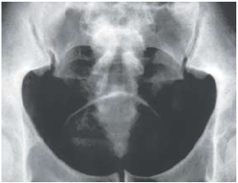

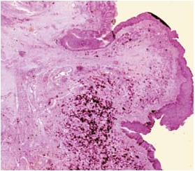

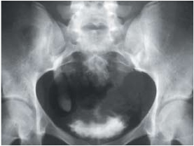

33. The Schistosomes

CNS schistosomiasis

Rarely, all three schistosomes induce focal inflam-
matory reactions within the central nervous system,
caused by deposition of eggs in the spinal cord and
the brain.45 S. mansoni and S. haematobium are more
likely to do so in the spinal cord, and S. japonicum in
the brain. Inflammation due to eggs may result in focal
transverse myelitis and encephalopathy.
Diagnosis

Definitive diagnosis is made by microscopically
identifying schistosome eggs in stool or urine (Figs.
33.4, 33.5a, 33.5b, 33.6). If a single stool examination
is negative, concentration of a specimen collected over
a 24-hour period is required, because the number of
eggs in stool can be few. Quantitative egg counts are
sometimes useful for epidemiologic studies attempting
to determine infection intensities. For light infections,
or in patients from whom egg excretion is intermittent

Figure . . Thigh of a child suffering from a maculo-
papular rash (“swimmer’s itch”) due to the cercariae of
a schistosome species that normally infects birds.

tion of immune complexes onto the glomerular mem-
brane.
S. haematobium, unlike the other three major
schistosomes, causes involvement of the urinary tract,
which is characterized by an inflammation to the eggs
as they are deposited in the wall of the bladder. Patients
with chronic S. haematobium infection develop hema-
turia as well as symptoms that mimic urinary tract infec-
tions such as dysuria and increased urinary frequency.
Over time the inflammatory changes in the bladder can
result in fibrosis that can lead to an obstructive uropa-
thy. This sometimes results in hydronephrosis or hydro-
ureter. The resulting urinary stasis can sometimes lead
to secondary bacterial urinary tract infections that may
exacerbate the scarring and fibrosis.
Bladder carcinoma

A unique type of bladder carcinoma occurs in
regions where S. haematobium is endemic. In contrast
to adenocarcinoma, the most common type of bladder
cancer in industrialized countries, some patients with
chronic S. haematobium go on to develop squamous
cell carcinoma. Squamous cell carcinoma is the most
common type of bladder cancer in parts of Egypt as
well as elsewhere in Africa. Possibly over time the S.
haematobium eggs function as a human carcinogen
that elicit metaplastic changes in the bladder.44
and from whom eggs cannot be found in stool, a rectal
biopsy can be carried out (Fig. 33.22). The tissue is
squashed between two microscope slides and exam-
ined under the low-power lens of a microscope. It is
helpful to refer to the specimen as a “rectal snip,” rather

Figure . 0. Cercaria of S. mansoni in skin sur-
rounded by eosinophils.
