CHS 224
Measures of population: (3)- mortality measurements

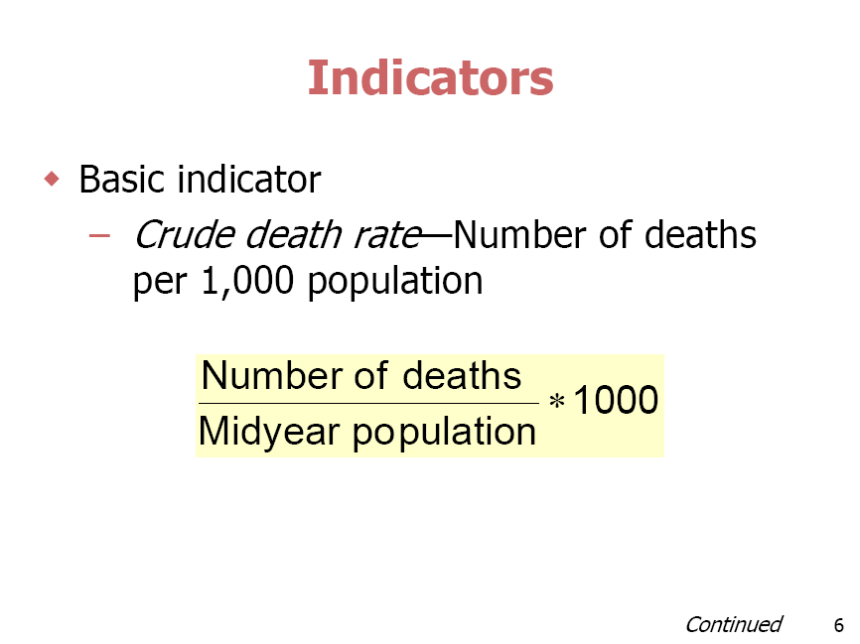
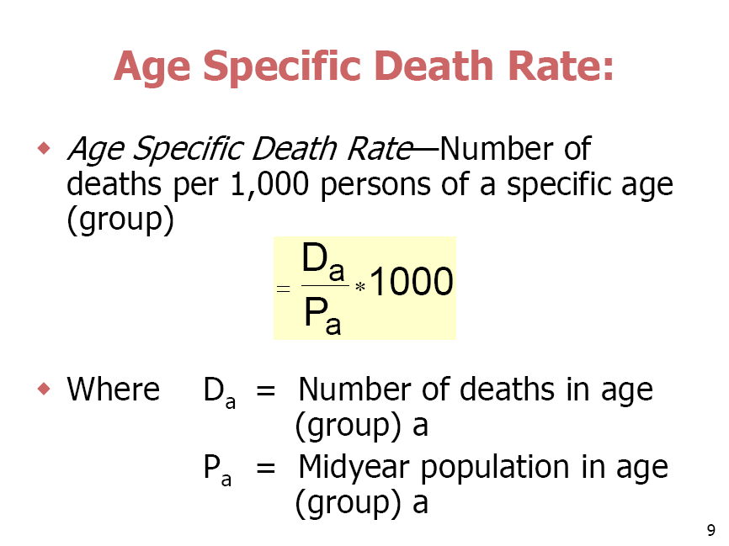
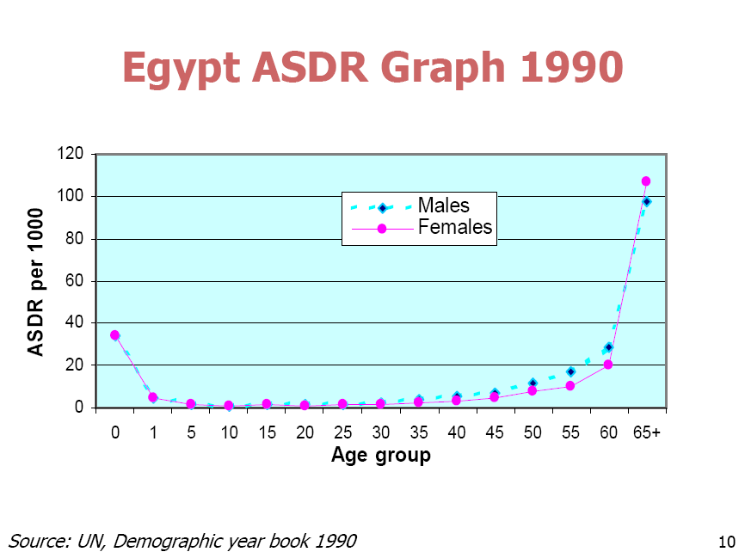

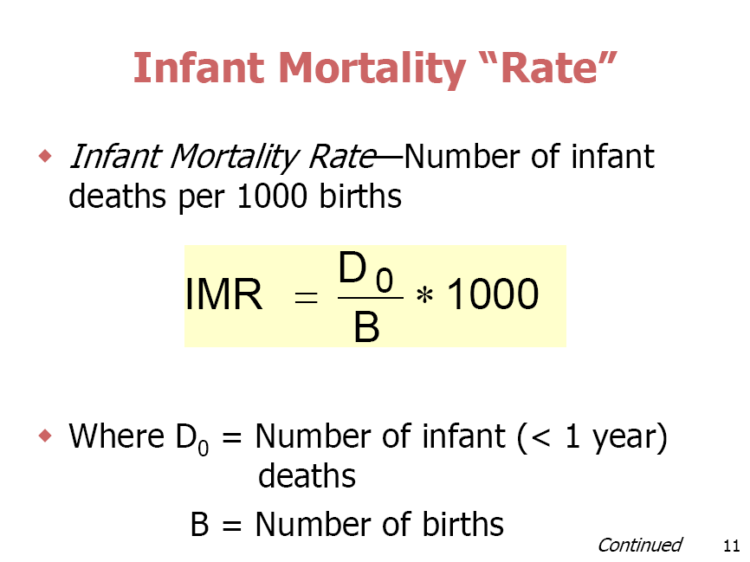
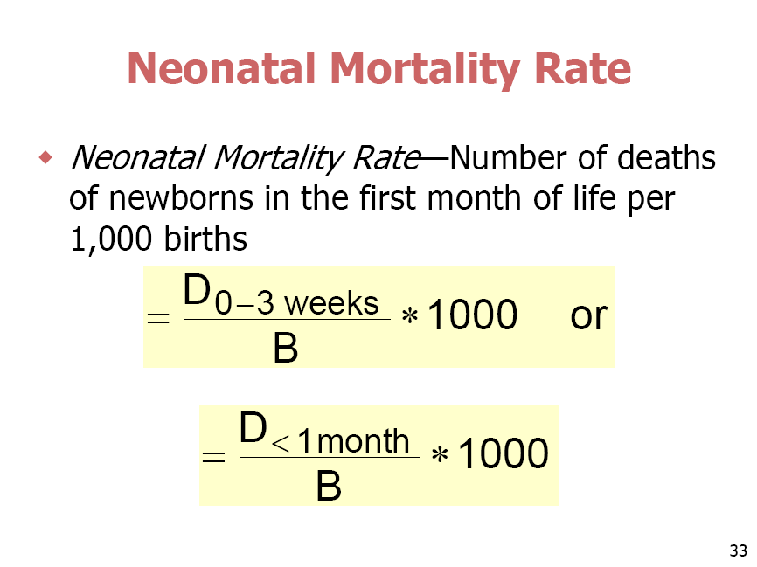
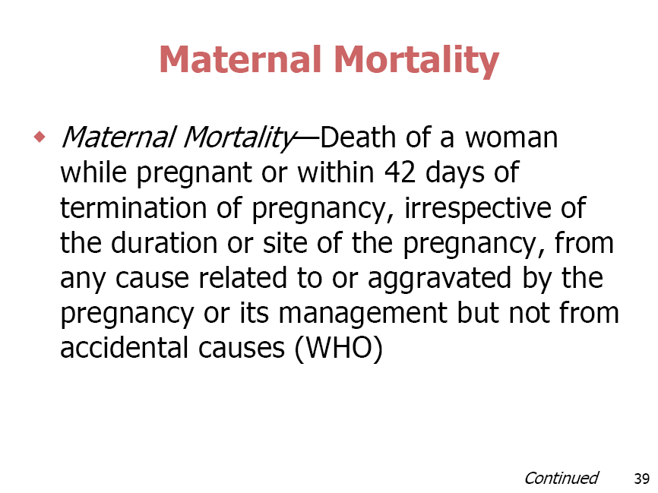

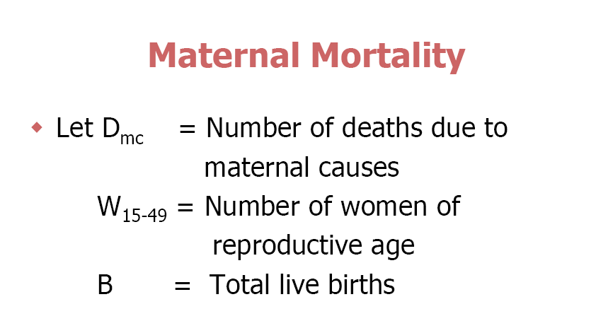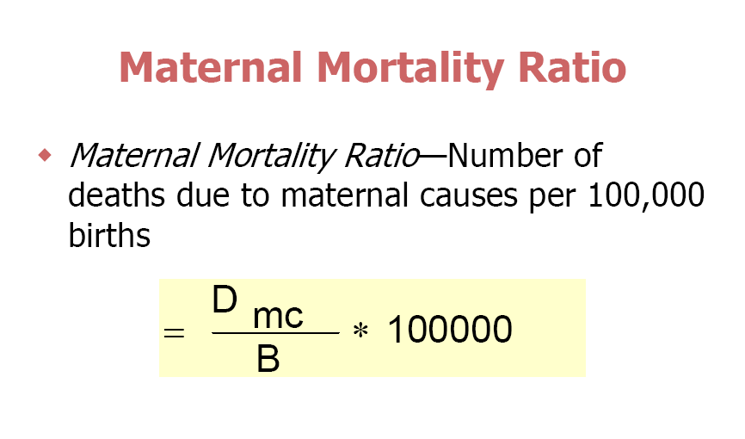

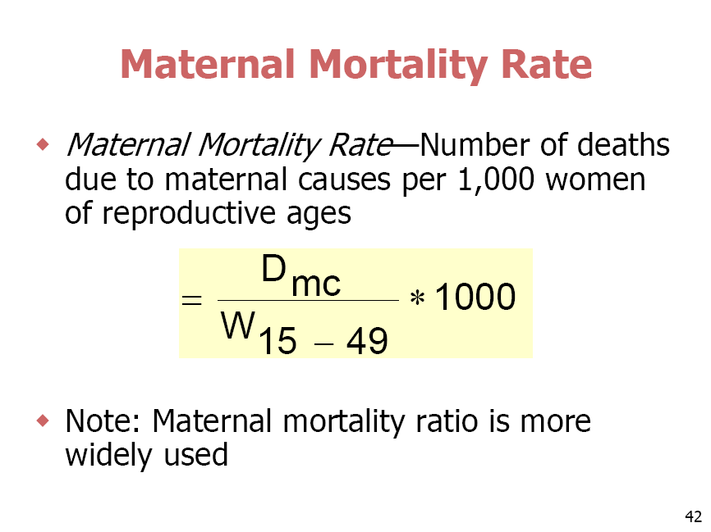
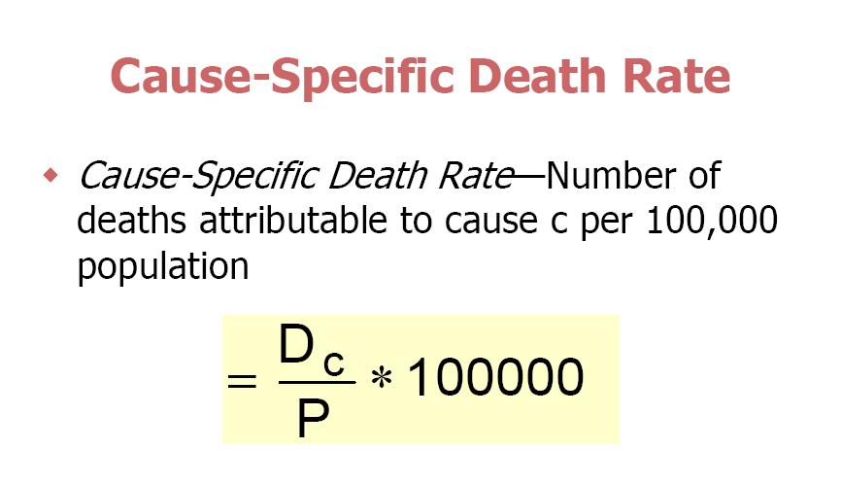
Workshop:
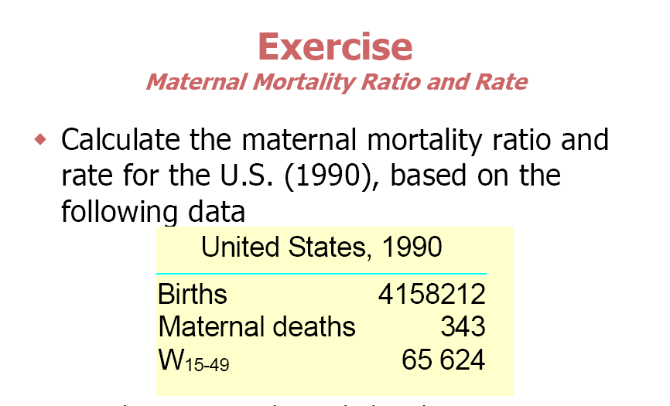

Calculate crude death rate and cause specific death rate for tuberculosis (TB) in a city in 1999, knowing that No of deaths from TB was 650 in that year and the total deaths were 2500, the mid year population was 200,523 individuals

In a city in the year 2006, there was 5600 births, 623 deaths among them 300 death in infants. The mid year population was 653000. Calculate the infant mortality rate.

