- Create new windows form application project then add new item

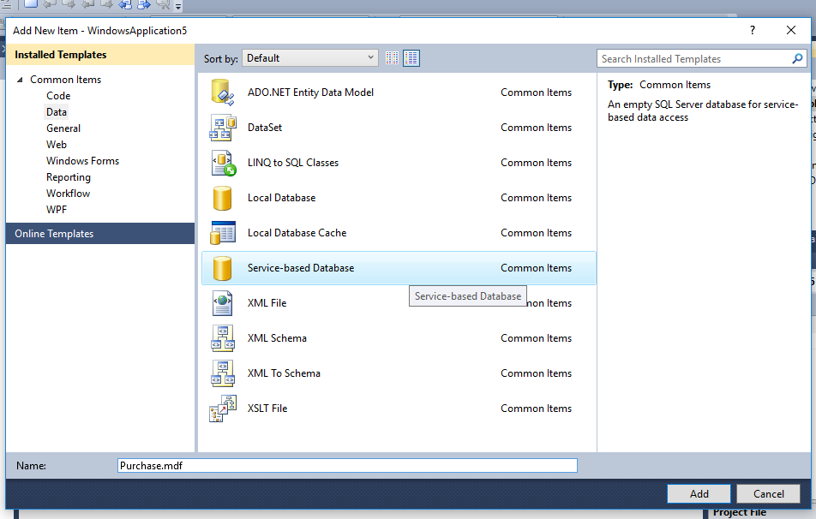

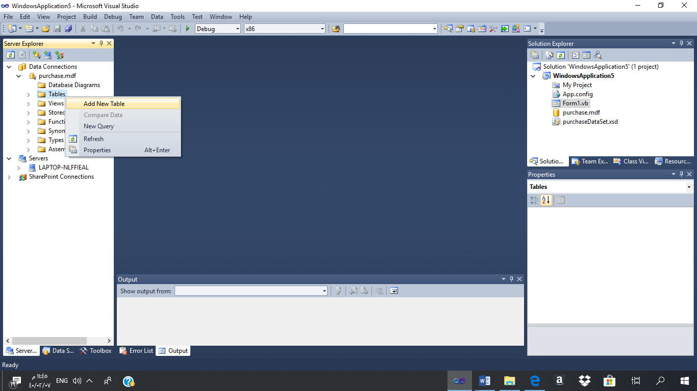

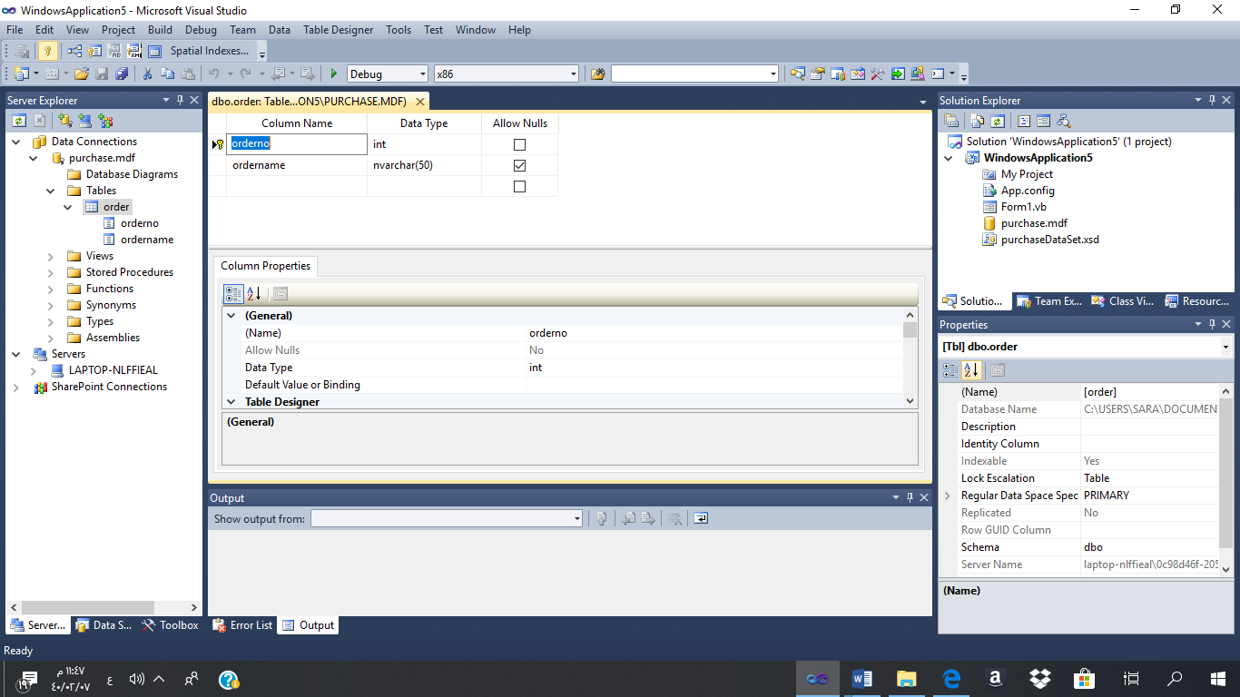

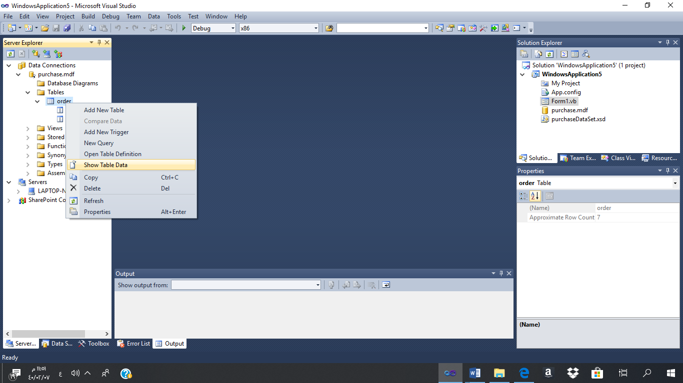
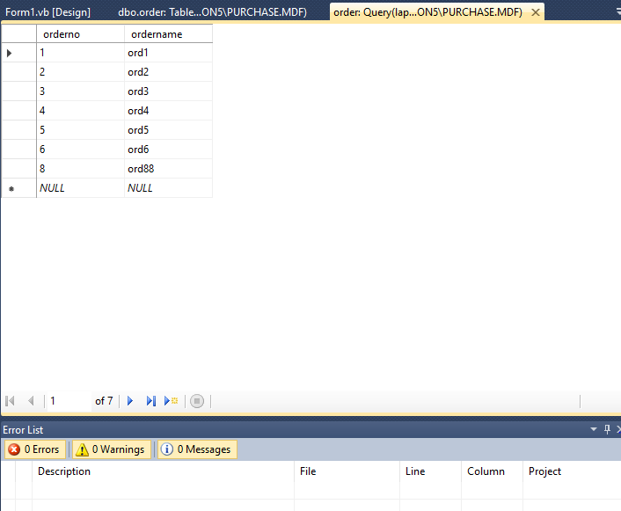
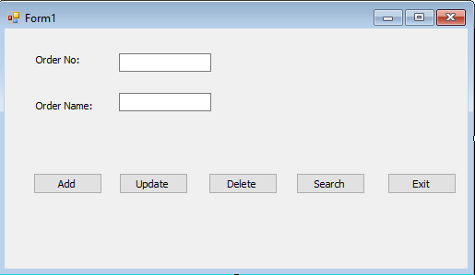

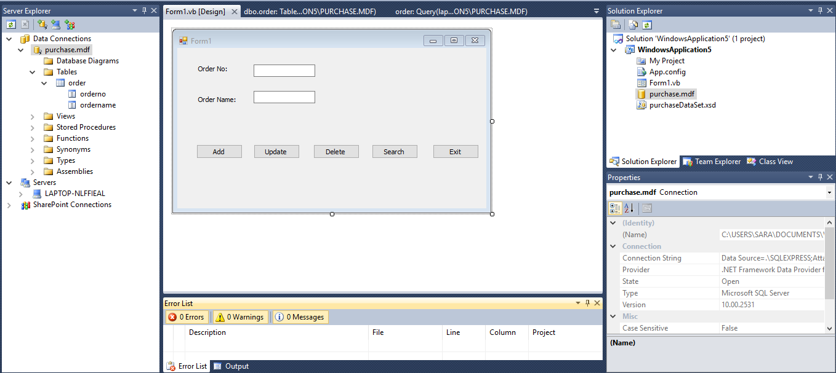

Imports System.Data.SqlClient
Public Class Form1
Dim con As New SqlConnection
Dim cmd As New SqlCommand

Private Sub Form1_Load(ByVal sender As System.Object, ByVal e As System.EventArgs) Handles MyBase.Load
con.ConnectionString = "Data Source=.\........................................."
End Sub

Private Sub Button1_Click(ByVal sender As System.Object, ByVal e As System.EventArgs) Handles Button1.Click
Try

cmd = New SqlCommand
cmd.Connection = con
cmd.CommandText = " insert into [order] values ('" & TextBox1.Text & "' ,'" & TextBox2.Text & "' ) "

con.Open()
cmd.ExecuteNonQuery()
MessageBox.Show("Success Insert")
Catch ex As Exception
MessageBox.Show("Error while inserting record on table...")
Finally
con.Close()
End Try
End Sub

Private Sub Button2_Click(ByVal sender As System.Object, ByVal e As System.EventArgs) Handles Button2.Click
Try

cmd = New SqlCommand
cmd.Connection = con
cmd.CommandText = "Update [order] SET ordername= '" & TextBox2.Text & "' WHERE OrderNo ='" & TextBox1.Text & "'"

con.Open()
cmd.ExecuteNonQuery()
MessageBox.Show("Success Update ")
Catch ex As Exception
MessageBox.Show("Error while updating record on table...")
Finally
con.Close()
End Try
End Sub

Private Sub Button3_Click(ByVal sender As System.Object, ByVal e As System.EventArgs) Handles Button3.Click
Try
cmd = New SqlCommand
cmd.Connection = con
cmd.CommandText = "DELETE FROM [Order] WHERE OrderNo = " & TextBox1.Text

con.Open()
cmd.ExecuteNonQuery()
MessageBox.Show("Success Delete")
Catch ex As Exception
MessageBox.Show("Error while deleting record on table...")
Finally
con.Close()
End Try
End Sub

Private Sub Button4_Click(ByVal sender As System.Object, ByVal e As System.EventArgs) Handles Button4.Click
Try

Dim reader As SqlDataReader

cmd = New SqlCommand
cmd.Connection = con
cmd.CommandText = "Select * From [Order] Where OrderNo = " & TextBox1.Text

con.Open()
reader = cmd.ExecuteReader

If (reader.Read()) Then
TextBox2.Text = reader("OrderName")

Else
TextBox2.Text = ""
MessageBox.Show("Order no " & TextBox1.Text & " not found")

End If
reader.Close()
Catch ex As Exception
MessageBox.Show("Error while retrieving record from table...")
Finally
con.Close()
End Try

End Sub

Private Sub Button5_Click(ByVal sender As System.Object, ByVal e As System.EventArgs) Handles Button5.Click
Me.Close()
End Sub

End Class

Sara

