**STAT436 project**

**منيرة فهد الجابر**

**434200947**

**Data: W8**

**Time Series Plot**

**(Non-stationary Time series)**

seasonal

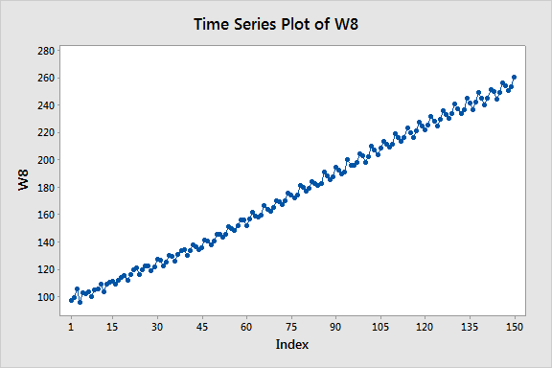

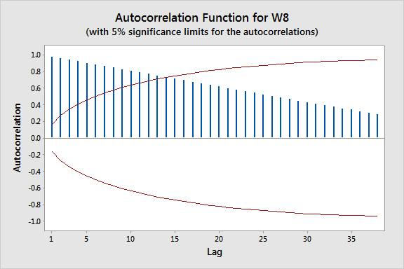**ACF & PACF**

**Non-stationary: Fail to die**

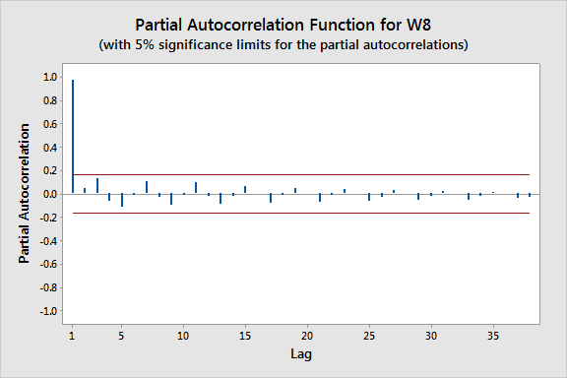

**Descriptive Statistics: W8**

Variable N Mean SE Mean StDev Minimum Median Maximum

W8 150 174.91 3.92 48.04 95.67 174.51 260.50

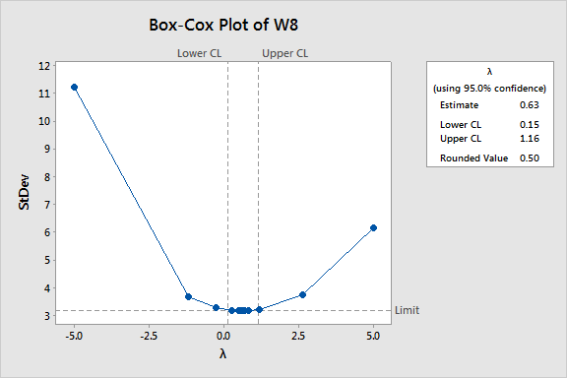**Transformation**

**MTB > Let C3 = SQRT(C1)**

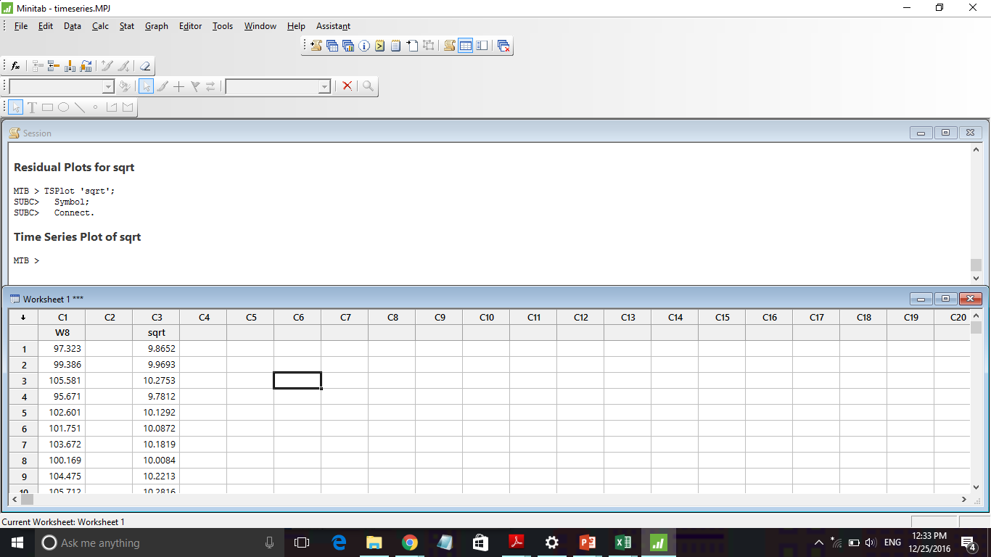

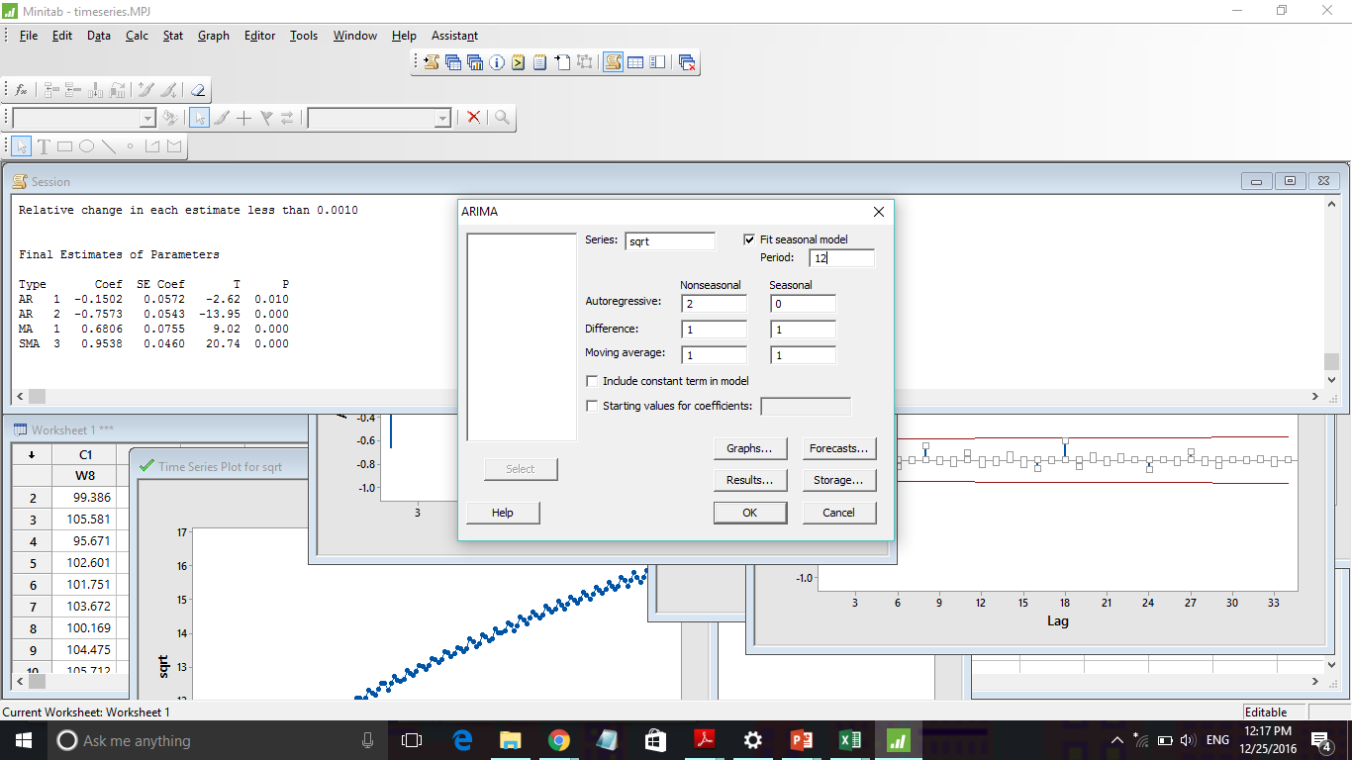**ARIMA (2,1,1) x**

