**A Rock Mechanical Model for Overbalanced, Managed Pressure,**

**and Underbalanced Drilling Applications**

Musaed N. J. AlAwad

*King Saud University, College of Engineering,*

*Petroleum and Natural Gas Engineering Department,*

*malawwad@ksu.edu.sa*

**Abstract**

In this work rock mechanics principles are used to elaborate a mathematical model to predict wellbore pressure required for safe overbalanced (OBD), managed pressure (MPD), and underbalanced (UBD) drilling based on laboratory evaluation of representative core samples from the formation to be drilled. The elaborated model combines the linear-poroelastic solution of stresses around circular boreholes and Mohr-Coulomb failure criterion. The model compares the induced stresses caused by the application of drilling (wellbore pressure) with the allowable induced stresses based on laboratory measurements of the formation mechanical properties (unconfined compressive strength and poison’s ratio), failure criteria (apparent cohesion and angle of internal friction), in-situ principle stresses, and wellbore trajectory (vertical, directional, or horizontal). Three hypothetical formations, very weak (ISRM grade R1), weak (ISRM grade R2), and medium strong (ISRM grade R3) rocks were used to illustrate the application of the model.

It was found that the safe windows for OBD and UBD drilling in vertical wells are much wider than those of the horizontal wells for all studied rocks. Also it was found that the safe drilling window width increases as the rock strength increases for both vertical and horizontal wells. Furthermore, it was found that it is extremely difficult to use UBD to drill horizontal wells parallel to the maximum principle horizontal in-situ stress in the very weak rock (R1) under the studied conditions. Therefore, the model in this paper provides a reliable tool for the prediction of optimum drilling window required for borehole stability and drilling safety.

**Keywords:** Underbalanced Drilling, Overbalanced Drilling, Managed Pressure Drilling, Linear Poroelastic, Mohr-Coulomb Failure Criterion

1. **Introduction**

The most common way of drilling a well today is by overbalance pressure (OBD). This method is the way it has been used since the beginning of the developing petroleum industry. By drilling overbalanced, the bottom hole (wellbore) pressure (Pw) is kept higher than the formation pore fluid pressure (Pp) at all times while drilling the well. To keep the well overbalanced at all times requires adjustments of the mud weight during the whole drilling operation. The designed mud weight must be lower than the formation fracture pressure, but higher than the formation pore fluid pressure. The main disadvantages of the conventional drilling (OBD) are: it is well-known drilling technique, its safety issues are very well known, requires fewer personnel to operate, more economical, requires less rig space, provides good borehole stability, and there is no need for handling of hydrocarbons during OBD. On the other hand, the main disadvantages of the conventional drilling (OBD) are: potential damage of the formation, potential mud loss to the formation, provides low rate of penetration through harder formations, potential for differential sticking, and potential for getting a kick in case of a section with unknown pore pressure. Recently, underbalanced drilling (UBD), and managed pressure drilling (MPD) techniques are developed (see Fig. 1). The size of the operational margin for UBD or OBD mainly depends on the formation strength.

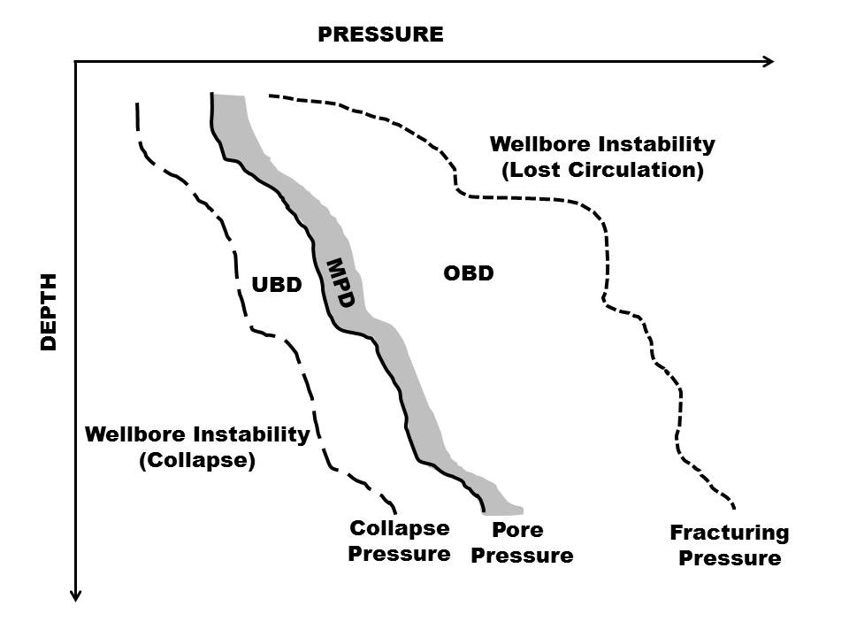

Fig. 1 Drilling windows for various types of drilling operations

Managed pressure drilling (MPD) is an adaptive drilling process to precisely control the annular pressure profile throughout the wellbore (Philip, 2006). MPD normally avoids the flow of the formation fluids into the wellbore and control, reduce drilling cost, and increase safety. Both UBD and MPD techniques employ a closed pressure-controlled system, making them ideal for pressure control. Managed Pressure Drilling (MPD) is a drilling tool that is increasingly being recognized by operators and regulators as it is able to enhance safety, efficiency and lower cost. MPD aims to resolve long-lasting drilling problems that contribute to non-productive time such as well instability, stuck pipe, lost circulation, and well control incidents. MPD is drilling with a controlled annulus and controlled returns to surface using an equivalent mud weight that is maintained at, or marginally above, formation pressure by manipulation of a dedicated choke device or other method. The key point is that reservoir fluid is not intended to reach the surface. The main advantages of managed pressure drilling (MPD) are: it improves rate of penetration (ROP), extends bit life, minimizes drillstring differential sticking, minimizes lost circulation, reduces the number of casing strings required to access the target, requires a simpler equipment package to satisfy safety considerations for the well, and reducing the day rate compared with UBD. In the other hand, the main disadvantages of the managed pressure drilling (MPD) are: may not be capable of solving the problems encountered, such as when fracture pressure is too close to pore pressure and when variations occur in pore and fracture pressures in different intervals within the same open hole. The third possible drilling operation is the underbalanced drilling (UBD). UBD is a procedure to drill oil and gas wells where the pressure in the wellbore is kept lower than the pressure of the fluid in the formation (reservoir) being drilled. In UBD, formation fluid flows into the wellbore and up to the surface. The major advantages of UBD are reducing formation damage in the reservoir, caused by mud solids and liquids invasion and shale swelling, maximizing hydrocarbon production, minimizing lost circulation, increasing drilling rates with certain rock types, extending bit life, reducing rock chip hold own, and minimizing the need for well stimulation. The disadvantages of the underbalanced drilling technique (UBD) are as follows: well instability, well control issues, and detection of kick need to be considered when choosing to utilize underbalanced drilling, drillstring vibrations are often more pronounced, Higher drag and torque will be experienced, surface cleaning equipment must be made available and may have to accommodate a complex mixture of fluids and cuttings, aeration of drilling fluids can create a complicated hydraulic profile, compressors will need to be rented, considerably increasing the daily drilling cost, an explosion potential exists due to the formation of hydrocarbon/oxygen mixtures and the frictional sources of ignition downhole, and air in contact with steel drillstring is a corrosion risk.

Based on the above introduction, it is clear that both MPD and UBD are candidates for drilling oil and gas bearing formations to avoid permeability damage as well as other instability problems when compared to the conventional OBD method. MPD is normally used in infill drilling in depleted reservoirs where the borehole stability is the main concern while UBD is normally used to drill well in newly developed reservoirs when formation damage is a big concern.

1. **Objective of The Study**

The objective of this work is to elaborate a mathematical model able to predict the wellbore pressure drop, balance, and overbalance (Pw) required for safe UBD, MPD, or OBD respectively based on rock mechanics principles and the laboratory characterization of representative core samples.

1. **The Mathematical Model**

Rock mechanics principles are used to solve many problems facing the oil industry such as sand production, wellbore instability, hydraulic fracturing, etc. (Musaed, 1998). In this work a mathematical model based on rock mechanics principals is elaborated to predict wellbore pressure required for safe underbalanced or overbalanced drilling processes. This model combines in-situ principal stresses, well inclination, well orientation, formation strength criteria and formation physical properties. Formation rock failure criteria are evaluated using Mohr-Coulomb failure criterion which is one of the most famous and applied rock failure criteria (Fjaer et al., 1992). This criterion is shown in Eq. (1):

 (1)

Three principal in-situ stresses acting deep in the earth are the vertical principal in-situ stress (v), the maximum horizontal principal in-situ stress (H) and the minimum horizontal principal in-situ stress (h). Wellbore instability can be predicted when these principal in-situ stresses are transformed parallel to the wellbore axis (for inclined or horizontal wells as shown in Fig. 2) using the following matrices (Fjaer et al., 1992; Musaed, 1997):

 (2)

 (3)

The drilling process generated an induced stresses are acting on the wall of a borehole (Jaeger, 1979). These are, the vertical induced stress (z), the radial induced stress (r) and the tangential induced stress () which can be computed using Eq. (4):

 (4)

By knowing the magnitude of the wellbore (mud) pressure, the induced principal stresses acting on the wall of a borehole can be computed as shown in Eq. (5):

 (5)

Finally, borehole instability using underbalanced drilling can be predicted by comparing the computed drilling induced and the experimentally measured shear stresses (i.e. failure criterion) as shown in Fig. 3 and Eqs. (6 to 8):

 (6)

 (7)

 (8)

Wellbore fracturing pressure limit can be estimated using the following relationship (Brady et al., 1985):

 (9)

Therefore, borehole instability (collapse) will take place if the model predicted (drilling) shear stress is equal or greater than the laboratory measured (failure criterion) shear stress. In the other hand, lost circulation (fracturing) occurs if the wellbore pressure exceeds the fracturing pressure of the formation. Table 1 lists the hypothetical data used to validate the mathematical model and to predict the wellbore pressure required for safe UBD, MPD, and OBD operations from wellbore instability prospects. These data are a modification of a real case vertical well of an oil field in china (Qiang, 2015). Three hypothetical formations were used, very weak (R1), weak (R2), and medium strong (R3) classified according to International Society for Rock Mechanics (ISRM, 1978). Full data is shown in Table 1.



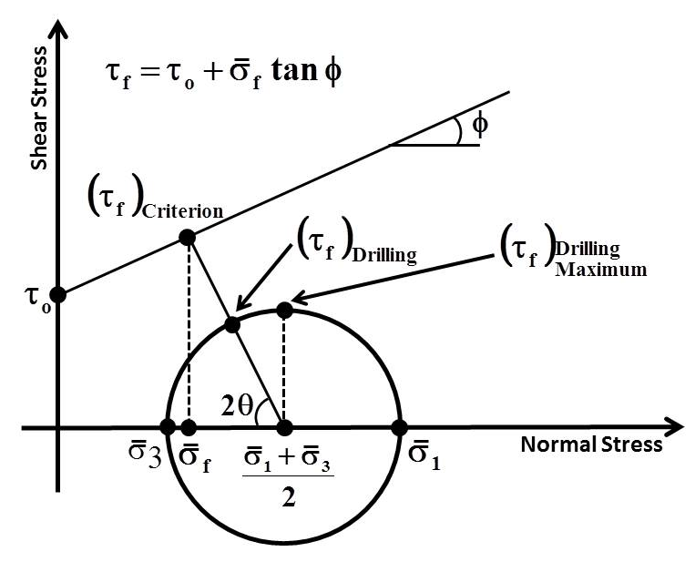Fig. 2 Stresses transformation for a directional well

Fig. 3 Representation of drilling induced failure possibility

Table 1 Hypothetical data used for model verification

|  |  |  |  |  |  |  |
| --- | --- | --- | --- | --- | --- | --- |
| Rock Type | ISRM  Grade | UCS, MPa | Poisson’s  Ratio | Friction Angle,  (Degree) | Depth,  m | Pore Pressure,  Pp, MPa |
| Very Weak | R1 | 6.9 | 0.20 | 21 | 2730 | 51 |
| Weak | R2 | 20.6 | 0.23 | 26 | 2730 | 51 |
| Medium Strong | R3 | 35.6 | 0.25 | 31.4 | 2730 | 51 |
| Principal In-Situ Stresses Gradients,  psi/ft (MPa/m) | | | |  | 1.10 (0.025) | |
|  | 1.00 (0.023) | |
|  | 0.93 (0.021) | |
| Angular Position around the Wellbore, degree | | | |  | Zero | |
| Wellbore Inclination from Vertical, degree | | | |  | Zero or 90 | |
| Wellbore Orientation Angle from, degree | | | |  | Zero or 90 | |

1. **Results And Discussion**

The developed model was used to predict the safe wellbore pressure required for safe underbalanced drilling, managed pressure drilling, and overbalanced drilling in vertical and horizontal wells in three types of formations (rock grades) (ISRM, 1978) namely, very weak (R1), weak (R2), and medium strong (R3) rocks as shown in Table 1. Figs. 4, 5, and 6 are the predictions for safe wellbore pressure windows for hypothetical vertical wells. For the very weak formation (R1), it was found that there are three safe possibilities to utilize OBD, MPD, and UBD with minimum wellbore pressure (collapse) and maximum wellbore pressure (lost circulation) limits of -19.4 MPa and +3.2 MPa respectively as shown in Fig. 4.

For the weak formation (R2), stable vertical wells can be drilled using UBD, MPD, or OBD. The minimum wellbore pressure (collapse) and maximum wellbore pressure (lost circulation) limits for this case are -29.2 MPa and +8.1 MPa respectively as shown in Fig. 5.

For the medium strong formation (R3), stable vertical wells can be drilled using UBD, MPD, or OBD. The minimum wellbore pressure (collapse) and maximum wellbore pressure (lost circulation) limits for this case are -39.4 MPa and +11.2 MPa respectively as shown in Fig. 6. It is clear that the safe drilling window was getting wider as the formation to be drilled is getting stronger as shown in Fig. 7. Table 2 summarizes all the studied cases.

For horizontal well drilling possibilities, it was found that it is unsafe to utilize UBD or MPD in the very weak (R1) formation and safe for both the weak (R1) and medium strong (R3) formations. The safe wellbore pressure for horizontal wells drilled parallel to the minimum horizontal principal in-situ stress in the medium strong (R3) formation is ranging between -38.2 MPa and +11.2 as shown in Fig. 8 and Table 3. For horizontal wells drilled parallel to the maximum horizontal principal in-situ stress in the medium strong formation (R3), the safe wellbore pressure range was -33.3 MPa to +11.2 MPa as shown in Fig. 9 and Table 3.

Data tabulated in Tables 2 through 5 are plotted in Fig. 10. It can be noticed that the safe drilling window decreases as the formation strength decreases. Furthermore, the most decease in drilling window was for the horizontal well drilled parallel to the maximum principal horizontal in-situ stress.

This difference is attributed to the difference in shear stresses at each orientation which is equal to 0.10 psi/ft (0.02 MPa/m) for horizontal wells drilled parallel to the maximum horizontal principal in-situ stress and 0.17 psi/ft (0.04 MPa/m) for horizontal wells drilled parallel to the minimum horizontal principal in-situ stress.

1. **Conclusions**

Based on the analysis of the output data obtained using the mathematical model and the hypothetical formation data presented in this study, the following conclusions are attained:

1. The application of UBD, MPD, or OBD is highly dependent on the formation strength, pore fluid pressure, and the in-situ principal stresses acting on the area.
2. In underbalanced drilling, the window of safe wellbore pressure for vertical wells is much wider than the window of the horizontal wells under the same conditions.
3. In overbalanced drilling, the same window was applicable in both vertical and horizontal wells under the same conditions.
4. In underbalanced drilling, the order of stability decrease (based on well configurations) are vertical wells, horizontal wells drilled parallel to the minimum horizontal principal in-situ stress, and horizontal wells drilled parallel to the maximum horizontal principal in-situ stress accordingly.

Fig. 4 Vertical well in very weak formation (R1)

Fig. 5 Vertical well in weak formation (R2)

Fig. 6 Vertical well in medium strong formation (R3)

Fig. 7 Summary of the studied vertical drilling cases

Fig. 8 Horizontal well (//H) in medium strong formation (R3)

Fig. 9 Horizontal well (//h) in medium strong formation (R3)

Table 2 Summary of the results of drilling vertical hypothetical wells in R1, R2 and R3 formations

|  |  |  |  |  |  |  |  |  |  |  |
| --- | --- | --- | --- | --- | --- | --- | --- | --- | --- | --- |
| Formation  Type | Well Type | UCS, MPa | Poisson’s Ratio | Friction Angle,  Degree | Safe Drilling Window, MPa | | | | | |
| OBD | | MPD | | UBD | |
| Pwc=  (Pw-Pp) | Pw | Pwc=  (Pw-Pp) | Pw | Pwc=  (Pw-Pp) | Pw |
| Very Weak (R1) | Vertical | 6.9 | 0.20 | 21 | +3.2 | 54.2 | 0 | 51 | -19.4 | 31.6 |
| Weak (R2) | Vertical | 20.6 | 0.23 | 26 | +8.1 | 59.1 | 0 | 51 | -29.2 | 21.8 |
| Med. Strong (R3) | Vertical | 35.6 | 0.25 | 31.4 | +11.2 | 62.2 | 0 | 51 | -39.9 | 11.1 |

Table 3 Summary of the results of drilling vertical and horizontal hypothetical wells in R1 formation

|  |  |  |  |  |  |  |  |  |  |  |
| --- | --- | --- | --- | --- | --- | --- | --- | --- | --- | --- |
| Formation Type | Well  Type | UCS, MPa | Poisson’s Ratio | Friction Angle,  Degree | Safe Drilling Window, MPa | | | | | |
| OBD | | MPD | | UBD | |
| Pwc =  (Pw-Pp) | Pw | Pwc =  (Pw-Pp) | Pw | Pwc =  (Pw-Pp) | Pw |
| Very Weak (R1) | Vertical | 6.9 | 0.20 | 21 | +3.2 | 54.2 | 0 | 51 | -19.4 | 31.6 |
| Horizontal// h | 6.9 | 0.20 | 21 | +3.2 | 54.2 | 0 | 51 | -17.3 | 33.7 |
| Horizontal// H | 6.9 | 0.20 | 21 | +3.2 | 54.2 | 0 | 51 | -1.9 | 49.1 |

Table 4 Summary of the results of drilling vertical and horizontal hypothetical wells in R2 formation

|  |  |  |  |  |  |  |  |  |  |  |
| --- | --- | --- | --- | --- | --- | --- | --- | --- | --- | --- |
| Formation Type | Well  Type | UCS, MPa | Poisson’s Ratio | Friction Angle,  Degree | Safe Drilling Window, MPa | | | | | |
| OBD | | MPD | | UBD | |
| Pwc =  (Pw-Pp) | Pw | Pwc =  (Pw-Pp) | Pw | Pwc =  (Pw-Pp) | Pw |
| Weak (R2) | Vertical | 20.6 | 0.23 | 26 | +8.1 | 59.1 | 0 | 51 | -29.2 | 21.8 |
| Horizontal// h | 20.6 | 0.23 | 26 | +8.1 | 59.1 | 0 | 51 | -27.5 | 23.5 |
| Horizontal// H | 20.6 | 0.23 | 26 | +8.1 | 59.1 | 0 | 51 | -16.6 | 34.4 |

Table 5 Summary of the results of drilling vertical and horizontal hypothetical wells in R3 formation

|  |  |  |  |  |  |  |  |  |  |  |
| --- | --- | --- | --- | --- | --- | --- | --- | --- | --- | --- |
| Formation Type | Well  Type | UCS, MPa | Poisson’s Ratio | Friction Angle,  Degree | Safe Drilling Window, MPa | | | | | |
| OBD | | MPD | | UBD | |
| Pwc =  (Pw-Pp) | Pw | Pwc =  (Pw-Pp) | Pw | Pwc =  (Pw-Pp) | Pw |
| Medium  Strong (R3) | Vertical | 35.6 | 0.25 | 31.4 | +11.2 | 62.2 | 0 | 51 | -39.9 | 11.2 |
| Horizontal// h | 35.6 | 0.25 | 31.4 | +11.2 | 62.2 | 0 | 51 | -38.2 | 12.8 |
| Horizontal// H | 35.6 | 0.25 | 31.4 | +11.2 | 62.2 | 0 | 51 | -33.3 | 17.7 |

Fig. 10 Safe drilling in three different horizontal well orientations and formations strengths

1. **Acknowledgment**

The author would like to thank King Saud University for supporting him to present this work in the 9th Asian Rock Mechanics Symposium, 18-20 October, 2016, Bail, Indonesia.

1. **References**

Brady, B. H. G. and Brown E. T., 1985, “Rock Mechanics for Underground Mining”, Published by *George Allen* & Unwin, London, England.

Fjaer E., Holt R. M., Horsrud P., Raaen A. R., and Risnes R., 1992, “Petroleum Related Rock Mechanics”, *Elsevier Science Publishers* B. V., Amsterdam, The Netherlands, 1st edition.

International Society for Rock Mechanics, 1978, “Suggested Methods for the Quantitative Description of Discontinuities in Rock Masses”, *Intl. J. Rock Mechanics and Mining Sciences & Geomechanics Abstracts*, V-15, pp. 319-368.

Jaeger J. C. & Cook N. G. W., 1979 “Fundamentals of Rock Mechanics”, 3rd edition, 593 pp., *Chapman and Hall,* London.

Musaed N. J. Al-Awad, 1998, “Rock Mechanics Applications in Petroleum Engineering Practices”, *Oil and Gas European Magazine*, Germany, December.

Musaed N. J. Al-Awad, 1997, “Investigation of Factors Affecting the Stability of Horizontal Oil and Gas Wells”, *SPE Technical Symposium*, Saudi Aramco, Dhahran, pp. 79-90, June 8-10.

Philip Frink, 2006, “Managed Pressure Drilling - What’s in a Name?”, *Drilling Contractor*, March/April.

Qiang Tan, Baohua Yu, Jingen Deng, Kai Zhao and Jianguo Chen, 2015, “Study on Wellbore Stability and Instability Mechanism in Piedmont Structures”, *The Open Petroleum Engineering Journal*, 8, 208-213.