Outcomes | To do list
Task sheet view,  Gantt chart and  Network diagram | - Create a Task sheet view or WBS Structure with normal durations for all activities )tasks(
Gantt chart and  Network diagram with  relationship  (Figures # 4, 5) | - Assign predecessors to all project activities (tasks')
Resource sheet,  Gantt chart and  network diagram,  resource sheet with  Over allocated  resources Task sheet  (Figures – 6,7,8,9,10) | - Enter the resources (both human and material) in the resource sheet and assign them to tasks.
Reports  (Figures -- 12, 1) | - Get the reports for Project summary, critical tasks.

- Description Project Idea.
- What problem we solve it in this project or what user require or result of this project.
- Create schedule for time for each phase in your project (figure #14)

CT1413 Lab 1: Submission of Lab Outcomes
1. Use a spare flash drive
2. Create a folder named:
CT1413_phase1_OUTCOMES_Team_NUMBER
(a note: substitute the word NUMBER in the folder name with the actual
number of your team).
3. Submit a flash drive with all Required Lab Outcomes (see above) to your
instructor by a designated in the course syllabus deadline.

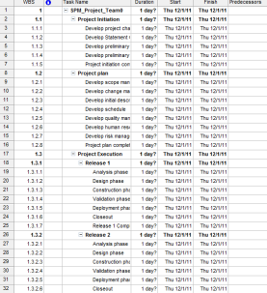
Figure 1: Team0_Phase1_Outcome_1a: Task Sheet View

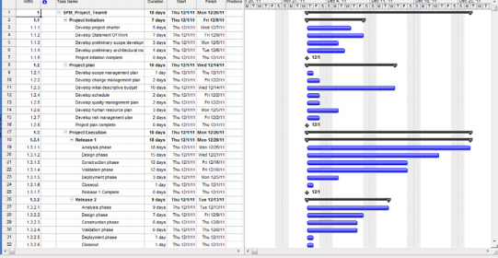
Figure 2: – Team0_Phase11_Outcome_1b: Gantt Diagram

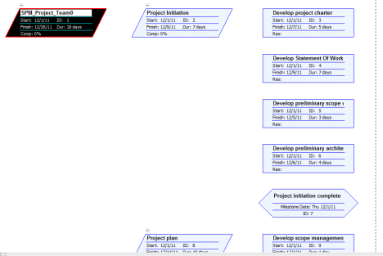
Figure 3: Team0_phase1_Outcome_1c: Network Diagram
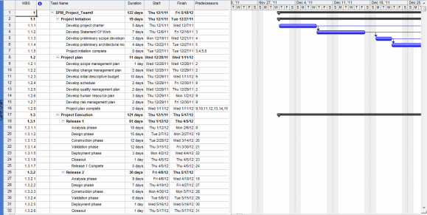
Figure 4: Team0_phase1_Outcome_2a: Gantt Diagram with relationships
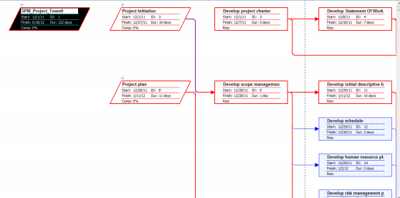
Figure 5: Team0_Phase1_Outcome_2b: Network Diagram with relationships
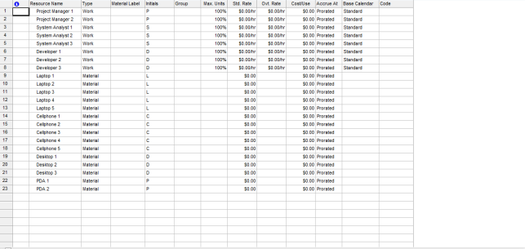
Figure 6: Team0_Phase1_Outcome_3a.mpp: Resource Sheet
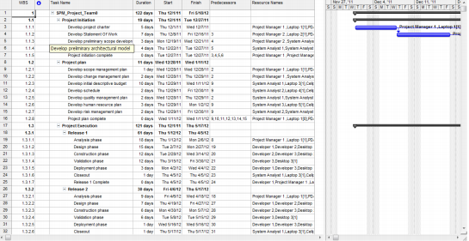
Figure 7: Team0_Phase1_Outcome_3b – Gantt Diagram with Resources Assigned

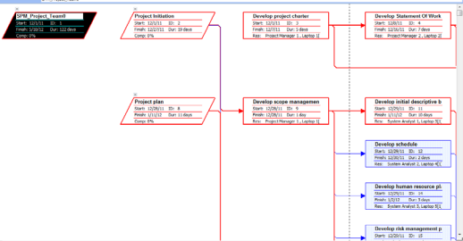
Figure 8: Team0_Phase1_Outcome_3c: Network Diagram with Resources Assigned
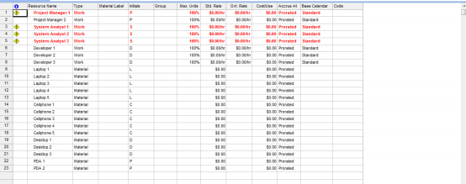
Figure 9: Team0_Phase1_Outcome_3d: Resources sheet with Over allocated resources (Shown in red color or the warning signs on the left of Resource Name column)
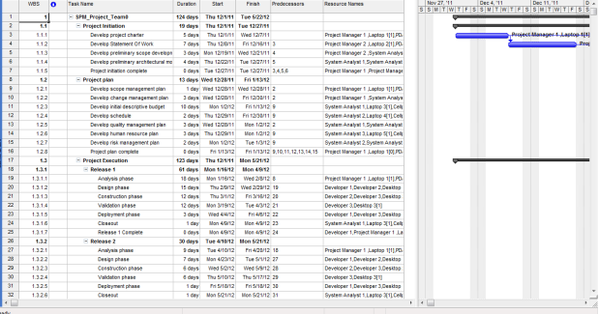
Figure 10: Team0_Phase1_Outcome_3e: Task sheet view after leveling the resources
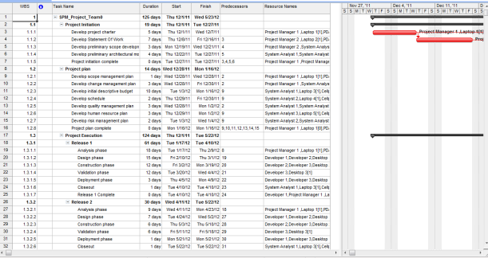
Figure 11: – Team0_Phase1_Outcome_5a: Critical path

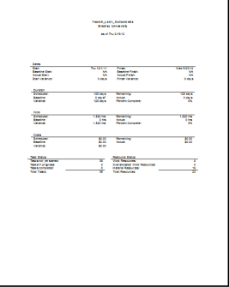
Figure 12: Team0_Phase1_Outcome_6a: Project summary Document
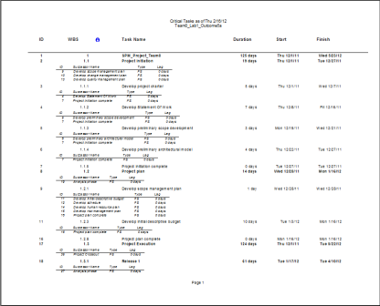
Figure 13: Team0_Phase1_Outcome_6b: Critical Tasks Document
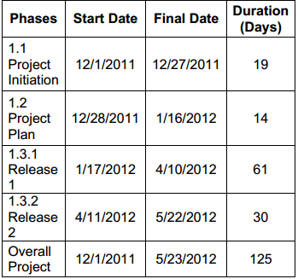
Figure 14: Team0_Phase1_Final _Outcome: Final Outcome Table

