ASMA ALAIBAN
By

PHC 516 Lab Report

Chloramphenicol palmitate

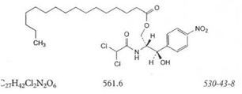

ASSAY
Dissolve 0.100 g in water R and dilute to 500.0 mL with the same solvent. Dilute 10..0 mL of this solution to 100.0 mL with water R. ،Measure the absorbance (2.2.25) at the maximum at 278 nm.
Calculate the content of C11H12CL2N2O5 taking the specific absorbance to be 297
Calculation:
A=abc A--- absorbance
a --- Absorptivity
b---bath length
c ---conc.
Theoretical conc.:
0.5 %
We have 0.1 gm
0.5 gm ----------------100 gms
0.1 gm --------------- ?
?=20 gms

2 bottels in volumetric flask complete to 500 mls

So the conc. Will be 0.1 gm ----500 mls
? ---100 mls
?= 0.02 gm/100 mls
Take 10 mls in volumetric flask complete to 100 mls
0.02 gm -----100mls
? ---- 10 mls
?= 0.002 gm /100 mls

$\% recovery =\frac{actual conc.}{Theoretical conc.} ×100$
Actual conc.:
A= 0.502
A=abc
0.502=297×1×C
∴ C= 1.69 ×10⁻³
$\% recovery =\frac{1.69 × {10}^{-3}}{0.002} ×100$= 84.5%
The rang is from ( 105- 95)
So reject the product.

Cyanocobalamin tabletS

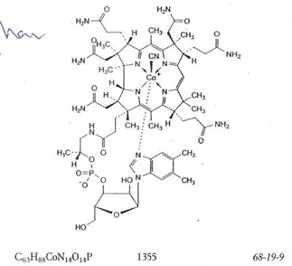

ASSAY
Dissolve 25.00 mg in water R and dilute to 1000.0 mL with the same solvent. Measure the absorbance (2.2.25), at the absorption maximum at 361 nm.
Calculate the content of C63H88CoN14O14P taking the specific absorbance to be 207.

Theoretical conc.:
1000µg 1 ml
1 mg --------------- 1 ml
6.25 mg ------ 250 mls
? ------100 mls
?=2.5 mg /100 mls
= 2.5× 10⁻³ gm

$$\% recovery =\frac{actual conc.}{Theoretical conc.} ×100$$
Actual conc.:
A= 0.695
A=abc
0.695=207×1×C
∴C= 3.357 ×${10}^{-3}$
$\% recovery =\frac{3.357× {10}^{-3}}{{2.5 ×10}^{-3}} ×100$ = 134.28 %
The rang is from (102- 96)
So reject the product.

Hydrocortisone Hydrogen Succinate

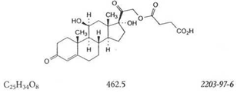

ASSAY
Dissolve 0.100 g in ethanol (96 per cent) R and diluted to 100 ml with the same solvent. Dilute 2.0 ml, of this solution To100.0 mL with to 100.0 m، with ethanol(96%)R. Measure at the absorbance (2.2.25) at the absorption 241.5nm.
Calculate the content of C25H34O8 taking the specific absorbance to be 353

Theoretical conc.:
0.1 gm cortisone --------------100 ml
? --------------- 2 ml
? = 2× 10⁻³gm

$$\% recovery =\frac{actual conc.}{Theoretical conc.} ×100$$

Actual conc.:
A= 0.821
A=abc
0.821=353×1×C
∴ C= 2.36 × 10⁻³ gm

$$\% recovery =\frac{2.36×{10}^{-3}}{2×{10}^{-3}} ×100=118\%$$

The rang is from (103- 97)
So reject the product.

Spironolactone

Spironolactone

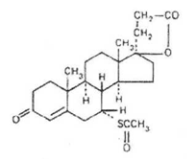

ASSAY
Dissolve about l0 mg, accurately weighed, in sufficient methanol R to produce 100 mL and dilute 10 mL of this solution to 100 mL with methanol R. Measure the absorbance of this solution in a 1-cm layer at the maximum at about 238 nm, and calculate the content of C24H32O4S, using the absorptivity value of 47
(A1%1 cm = 470).
Theoretical conc.:
10 mg spironolactone --------------100 ml
1 mg --------------- 10 ml
Dilute 10 mls to 100 mls
∴ 1 mg ------------ 100 mls
∴ 1 × 10⁻³ gm/100 mls

$$\% recovery =\frac{actual conc.}{Theoretical conc.} ×100$$

Actual conc.:
A= 0.906
A=abc
0.906=470×1× C
∴ C= 1.93 ×10⁻³ gm %

$$\% recovery =\frac{1.93×{10}^{-3}}{1×{10}^{-3}} ×100=193\%$$

The rang is from (101.5- 97%)
So reject the product.

Betamethasone Valerate

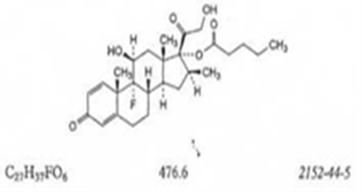

ASSAY
Dissolve 50.0 mg in ethanol (96 per cent) R and dilute to with the same solvent. Dilute 2.0 ml. of this solution to 50.0 mL with ethanol (96 per cent)R. Measure the absorbance(.(2.2.25 at the absorption maximum at 240 nm
Calculate the content of C27H37FO6 taking the specific absorbance to be 325 .

Theoreticalconc:
50 mg --------------100 ml
? ---------------2 ml
?= 1mg
Dilute 2.0 ml. of this solution to 50.0 mL
∴ 1 mg ------------ 50 mls
? ---------- 1mls
?= 0.02 mg
= 0.002 gm%

$$\% recovery =\frac{actual conc.}{Theoretical conc.} ×100$$

Actual conc:
A= 0.26
A=abc
0.26 =325$×$1$×$C
∴C= 8$×$10⁻⁴
$$\% recovery =\frac{8×{10}^{-4}}{0.002} ×100=40\%$$

The rang is from (103- 97%)
So reject the product.

Zinci sulfas - Zinc sulfate

ASSAY
For the monohydrate Dissolve about 80 mg,_accurately weighed, in 5 ml of acetic acid (~120 g/I) TS and proceed with the titration as described under 2.5 Complexometric titrations for zinc. Each mL of disodium edetate
(0.05 mol/l) VS is equivalent to 8.975 mg of ZnS04/H20.
For the heptahydrate Dissolve about 0.13 g, accurately weighed, in 5 mL of acetic acid (~120 g/I) TS and proceed with the titration under 2.5 complexometric titrations for zinc. Each mL of disodium edetate (0.05 mol/l) VS is equivalent to;14.38 mg of ZnS04,7H20.

Zinc
Dissolve the quantity of substance, accurately weighed, as specified in the monograph, in 5-10 mL of water, acidified with a minimum quantity of acetic acid (~300 g/l) TS if necessary, and then dilute to about 50 mL with water. Add about 50 mg of xylenoL orange indicator mixture R and sufficient methenamine R (about 5 g) to turn the solution pink-violet and titrate with disodium edetate"(0.05 mol/l) VS until the solution turns from pink-violet to full yellow. Each mL of disodium edetate (0.05 mol/l) VS is equivalent to 3.268 mg of Zn.
Theoretical conc: (end point)
For ZnS04
1 gm --------------1000 mg
0.13 gm --------------- ?
?= 130 mg
14.38 mg of ZnS04--------- 1ml of EDTA
130 mg --------- ?
? = 9 ml

Actual conc:( actual end point )
EDTA M.WT =372.24
372.24 mol/l -----------1 mol
?----------- 0.05 mol/l
? = 18.61
$$\% recovery =\frac{18.61}{9} ×100=206\%$$
Zinc sulfate monohydrate contains (99.0% -101.0% )of ZnS04/H20.
Zinc sulfate heptahydrate contains (99.0% -104.0%) of ZnS04,7H20.
So reject the product.

Ibuprofenum -Ibuprofen

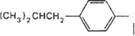
CH3
CHCOOH

C13H1802

ASSAY
Dissolve about 0.4 g, accurately weighed, in 100 mL of etfianol (~750 g/I) TS previously neutralized to"pBenolphthalein/ethanol TS, and titrate~~with carbonafe-free sodium hydroxide (0.1 mol/l) VS, using phenolphthalein/ethanol TS as indicator. Repeat the operation without the substance being examined and make any necessary corrections. Each mL of carbonate-free sodium hydroxide (0.1 mol/l) VS is equivalent to 20.63 mg of C13H1802.

Theoretical conc =(end point)
For C13H1802.
0.4 gm --------------100 ml.
? --------------- 1 mls
?= 4 × 10-3 gm/ 1ml
= 4 mg / 1 ml
0.1 mol/l

for NAHO
40 gm /l-------------- 1 mol
? ------------ 0.1mol
?= 4 gm

Ethanol:
To change g mls by specific gravity = 0.787 g/mlcm3

$$Ethol=\frac{750 g }{0.787 g/ml}=952ml$$
952 ml----------- 1l
95.2 ml---------- 100 ml
End point= E.P – Blank
Blank = 0.5
∴ 12.5 -0.5 = 12
1 ml ------- 20.63 mg of C13H1802.
12 ml------ ?
? = 247.56

Actual conc =( actual end point )

0.4 gm × 1000 = 400 mg
20.63 mg ----------- 1 ml
400 mg ----------?
? = 19 ml

$\% recovery =\frac{247.56}{400} ×100$ = 61.89%

Ibuprofen contains (98.5% -100.5%)of C13H1802
So reject the product.

Aspirin

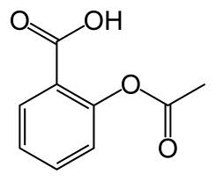

C9H8O4

Assay:
Aspirin is an acid. The active ingredient is acetyl salicylic acid. Differentstrengths of aspirin are based on the amount of active ingredients that they contain.
Titration is a way to determine how much acid is in a solution by adding just enough base of a known concentration to neutralize the acid.
The aspirin will be Potentiometric titrated against a standard solution of base, 0.100 N NaOH.
After dissolving of ASA( 1 tab.) in 40 mls Ethanol 96%.

mls | P H  5.6 8.87  5.7 9.24  5.8 10.12  5.9 11  6.0 11.6  6.1 12.1  6.2 12.5  6.3 12.6  6.4 12.7  6.5 12.8  6.7 13  6.8 13.1  6.9 13.15  7.0 13.2
0.0 | 4.15
0.5 | 5
1.0 | 6
1.5 | 6.8
2.0 | 6.95
2.5 | 7.1
3.0 | 7.26
3.5 | 7.45
4.0 | 7.63
4.1 | 7.66
4.2 | 7.72
4.3 | 7.73
4.4 | 7.75
4.5 | 7.76
4.6 | 7.79
4.7 | 7.84
4.8 | 7.89
4.9 | 7.94
5.0 | 8
5.1 | 8.07
5.2 | 8.15
5.3 | 8.23
5.4 | 8.45
5.5 | 8.65

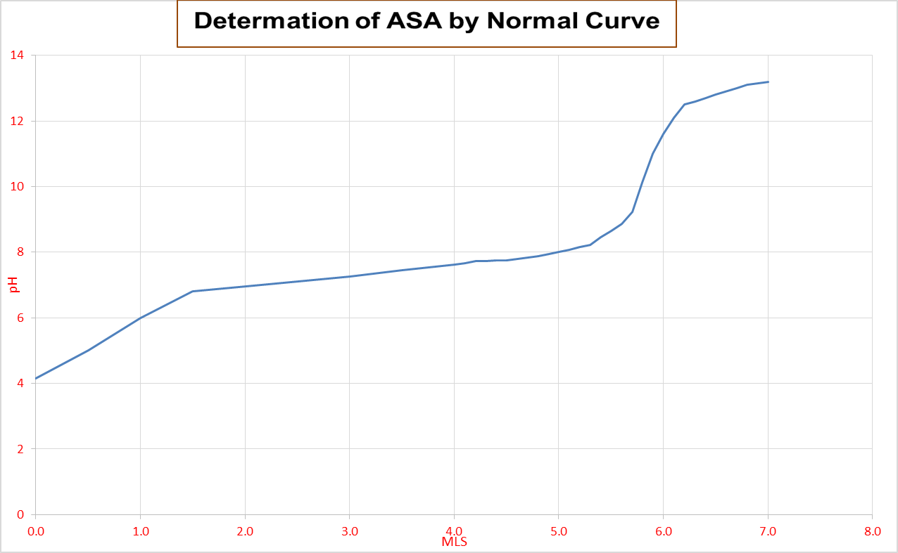

Calculation:
The weight of 1 tab. = 6 gm
Take 10 tablets --------------- so it will= 6/10 = 0.6 gm

Actual conc. = E.P *F*f

F= M.WTof ASA * N of titrant.
= 180.157 * 0.1
= 18

Calculated E.P = conc.of ASA
F
= 81/18 = 4.5 mls

Actual conc. = E.P *F*f
= 5.8 * 18.1* 1
= 104.9

% Recovery = actual conc. $×$ 100
Theoretical strength

= 104.9 $×$ 100
81

= 129.6%
the range ( 105 -95 %)
So reject the product.

Thank you

