Time series , ACF and PACF for the data

 





Since the value of lamda is equal to zero it can be transformation to two formats and it will give me the same result .

 

 

 

The transformation dosen’t give me any things .

Fitting the model :

ARIMA(2,1,3)







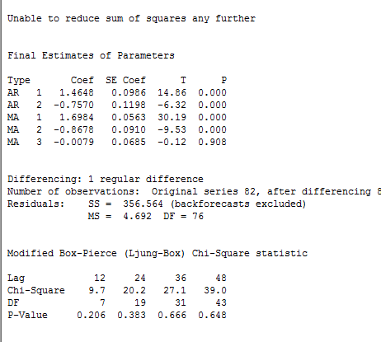

Fitting the model :

ARIMA (2,1,0)\*(1,0,0) 30









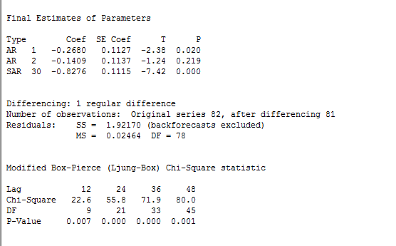

Fitting the model :

ARIMA(0,2,2)









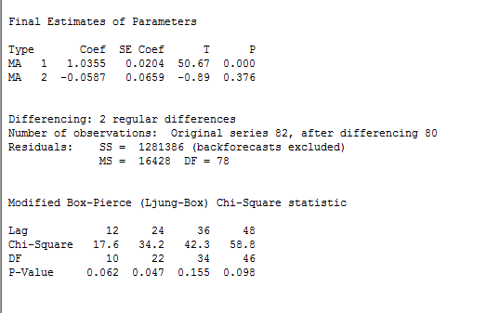

Rana ALMIHIYNI

434201062