TIME SERIES

TIME SERIRES PLOT

ACF

PACF

TRANSFORMATION

DIFFERENCE

PLOTS OF RESEDIUSL

TIME SERIRES PLOT



ACF



PACF



TRANSFORMATION



LAMDA IS 4

TIME SERIES FOR THE DEFERENCE OF (W11) 

FITTING THE MODEL

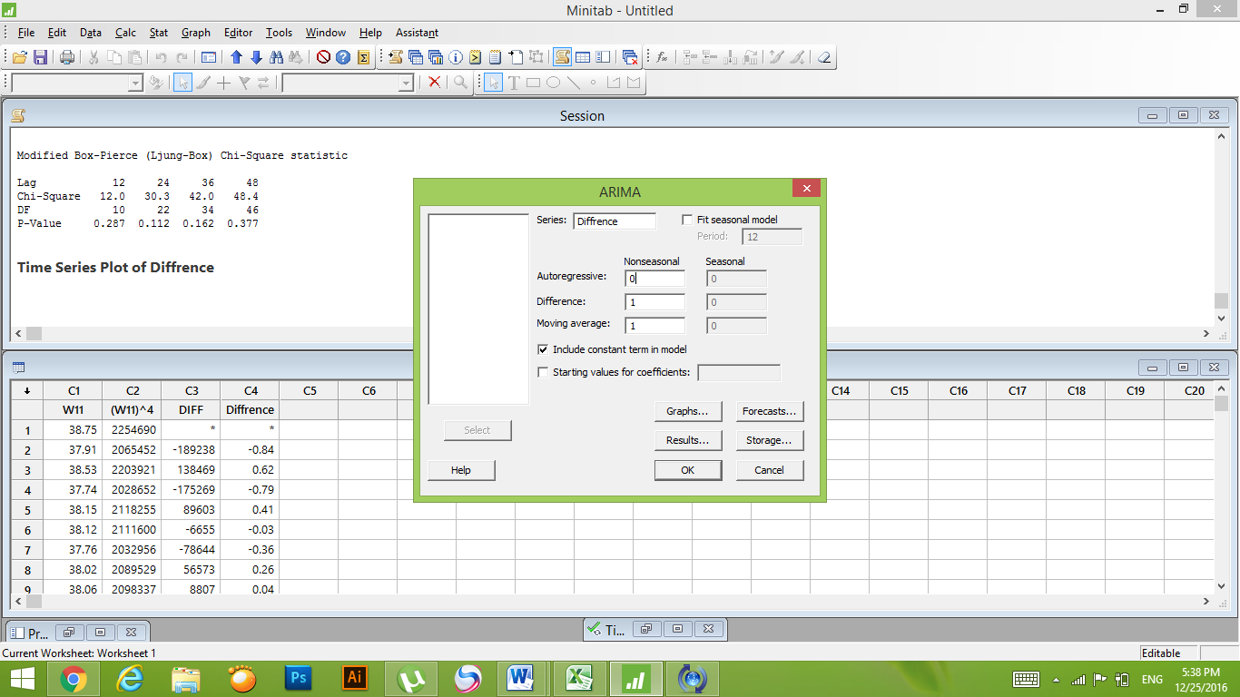

**ARIMA Model: Diffrence**

Estimates at each iteration

Iteration SSE Parameters

0 215.958 0.100 0.103

1 187.953 0.250 0.057

2 166.394 0.400 0.030

3 149.378 0.550 0.013

4 136.006 0.700 0.004

5 126.135 0.850 0.001

6 121.816 0.940 0.002

7 120.592 0.969 0.001

8 119.205 0.991 0.000

9 118.665 1.001 -0.000

10 118.186 1.001 0.000

11 118.158 1.001 0.000

12 118.119 1.002 0.000

Relative change in each estimate less than 0.0010

Final Estimates of Parameters

Type Coef SE Coef T **P**

MA 1 1.0016 0.0002 5931.64 **0.000**

Constant 0.0002777 0.0009516 0.29 0.771

**P – VALUE < 0.05**

Differencing: 1 regular difference

Number of observations: Original series 165, after differencing 164

Residuals: SS = 117.545 (backforecasts excluded)

MS = 0.726 DF = 162

Modified Box-Pierce (Ljung-Box) Chi-Square statistic

Lag 12 24 36 48

Chi-Square 12.0 30.3 42.0 48.4

DF 10 22 34 46

**P-Value 0.287 0.112 0.162 0.377**

**P – VALUE > 0.05**

ACF OF RESIDUALS



PACF OF RESIDUALS



RESIDUALS PLOTS

