Report Evaluation 2
The lab report includes the following:
- Answer Q1and Q2
- Applying VLSM for the following topology:
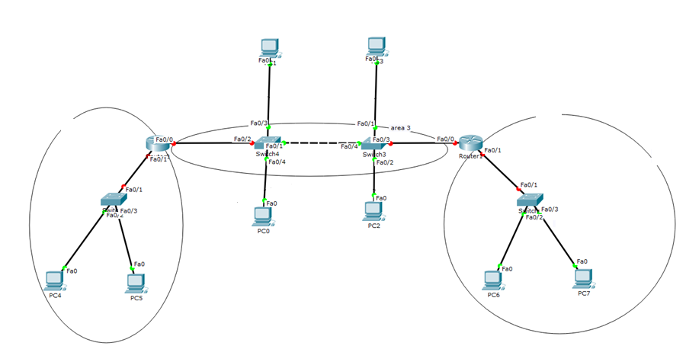

- Questions and discussions:
  - What is the last valid host on the network that 10.242.38.128/11 is a part of?

  - What is the maximum number of valid hosts one will have from the network 192.168.14.0/29

  - What is the broadcast address of the network 10.74.45.58 255.192.0.0

