**Question #1:** Write the following Programs in Visual Basic:

1. ***(Factorial of a Number)*** Write a program that calculates the factorial of a number using one of the repetition statements that you have learn. Example the factorial of number 3 is 6 (because: 1 x 2 x 3 = 6).



1. Write a program that reads an integer number X and prints only the even numbers between 1 and X.

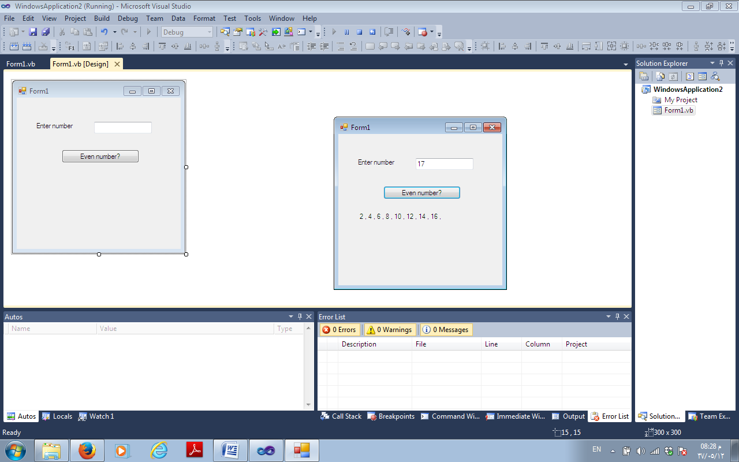

1. **Bonus:**

Write a program that reads an integer number and prints its components. For example: 5628 is component of: 8, 20, 600 and 5000. Note (use mod and \ to solve this problem). Use do loop while.

