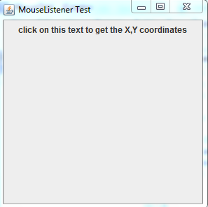
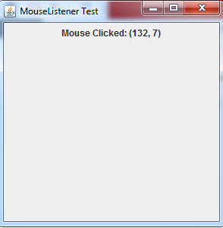
Write a java application using mouse listener. When the user clicks on the panel the program shows the coordinates of the mouse click.

import java.awt.event.MouseListener;
import java.awt.event.MouseEvent;

import javax.swing.*;
import javax.swing.JPanel;
import javax.swing.JTextArea;

public class MouseTest extends JFrame implements MouseListener
{
//JTextArea exitText = new JTextArea(2, 10);
JLabel statusLabel = new JLabel("click on this text to get the X,Y coordinates");

public MouseTest() // Frame constructor
{

JPanel p = new JPanel();

p.addMouseListener(this);

p.add(statusLabel);

getContentPane().add(p);
setTitle("MouseListener Test");
setSize(300,300);
setDefaultCloseOperation( EXIT_ON_CLOSE ); // important
setVisible(true);
}

public static void main(String[] args)
{
MouseTest MT = new MouseTest(); // new object of frame
}

//when the mouse is clicked on the Component
public void mouseClicked(MouseEvent e)
{
statusLabel.setText("Mouse Clicked: ("+e.getX()+", "+e.getY() +")");
}

//when the mouse enters the Component
public void mouseEntered(MouseEvent e)
{
}

//when the mouse leaves the Component
public void mouseExited(MouseEvent e)
{
}

//when the mouse left button is held down on the Component
public void mousePressed(MouseEvent e)
{
}

//when the mouse left button is released on the Component
public void mouseReleased(MouseEvent e)
{
}
}

