Q1. Using Graphics capabilities draw the following diagram.

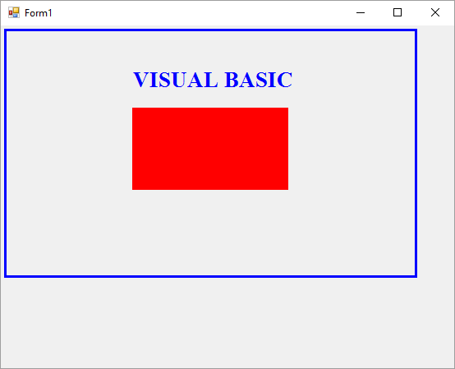
(350,200)
(160,200)
(350,100)
(160,100)
Hint:
- Use white color to fill the background rectangle
- The background rectangle starting point is (5,5) , width = 500 and Height = 300
- The string starts in point (150, 50), color is blue, and style is bold.
- The Polygon color is red.

