Strategy | Search Cost | Path Cost | Space Cost | Goal State | Goal Test Application
DFS | 11 | 14 | 5 | T | ABEKLFMST
BFS | 20 | 7 | 8 | R | ABCDEFGHIJKLMONOPQR
UCS | 12 | 7 | 7 | R | ADBCIJQR
A* | 7 | 7 | 4 | R | ADJR
Solution Q # 1.

Solution Q. # 2
- Search cost is determined by the total number of nodes generated during a search, while path cost is determined by the sum of cost of all nodes from initial (start) state to goal state.
- The computer passes the “test of intelligence” if a human, after posing some written questions, cannot tell whether the responses were from a person or not. The test was proposed by A. Turing in 1950’s.
- A heuristic function is a function f(n) that gives an estimation on the “cost” of getting from node n to the goal state – so that the node with the least cost among all possible choices can be selected for expansion first.
- It is important to use admissible heuristic function to assure optimality.
- It is important to use accurately admissible function for A * to reduce the search cost.
- The main advantage of alpha –beta pruning lies in the fact that some nodes are pruned out and are not visited, thus reducing the time cost to foster the search results.
- AI can be seen as a thoughtful action, as the algorithms and search techniques use the theoretical knowledge to solve the real life problems.
- Local search Techniques use little memory and more applicable in searching large/infinite search space. As a disadvantage they may return suboptimal solutions.
- Hill climbing search uses a single state and tries to improve on that while GA uses multiple states at a time.
- Hill climbing search uses a single state and tries to improve on that while simulted enaling escapeslocal mexima by allowing some bad moves butgradually decreses their frequency.
Solution Q # 3
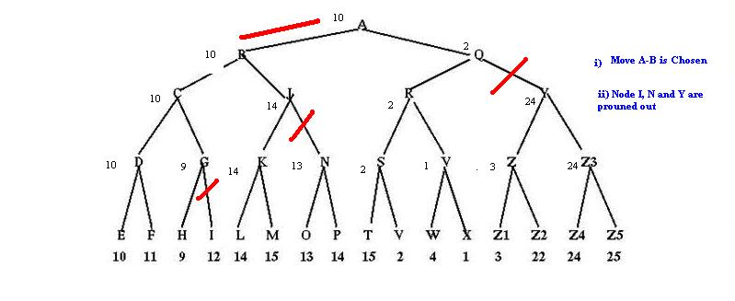
Exam Result
 | Stu ID | 30 | 30 | 17 | 23 | Total
1 | 429104429 | 24 | 22 | 11 | 11 | 68
2 | 429104491 | 30 | 24 | 16 | 9 | 79
3 | 427101700 | 30 | 18 | 15 | 11 | 74
4 | 423105681 | 15 | 9 | 12 | 4 | 40
5 | 429104864 | 16.5 | 4 | 14 | 1 | 35.5
6 | 429103682 | 27 | 22 | 16 | 5 | 70
7 | 429101913 | 30 | 23 | 17 | 23 | 93
8 | 429101715 | 27 | 27 | 16 | 15 | 85
9 | 429101248 | 30 | 9 | 15 | 1 | 55
10 | 429101822 | 30 | 21 | 12 | 3 | 66
11 | 428102315 | 28.5 | 15 | 17 | 6 | 66.5
12 | 429102034 | 25.5 | 14 | 17 | 8 | 64.5

