بســم اللــه الرحمــن الرحيـــم
Superpave Mix Design

Introduction :
Superpave procedure is considered as an improved method for producing a good performing asphaltic paving mix. It is a short name for Superior Performing Asphalt Pavement. It was developed in 1987 by the Strategic Highway Research Program (SHRP) researchers. It is an improved system for specifying asphalt binders and mineral aggregates, designing asphalt mixtures, and predicting pavement performance . In this method of mix design, the specifications is considered as a performance - based rather than empirical as in Marshall method. The tests and analyses followed in this method have direct relationships to field performance. The binder tests measure the physical properties at temperatures and aging conditions that more realistically represents those encountered by in-service pavements.
The Superpave mixture design and analyses system uses three rigorous degrees of testing and analyses to produce a well performing mixture for a given pavement project ; which include :
- Careful material selection and volumetric proportioning .
- intermediate mix testing and analyses in order to optimize the asphalt mixes based on estimate of pavement performance. ( for critical, high traffic volume projects ).
- Advanced (complete) mix testing and analyses in order to get better optimization of the asphalt mixes through sophisticated estimate of pavement performance . ( for more critical, higher traffic volume projects ).
This handout describes the material selection and volumetric proportioning part of the Superpave mix design (volumetric design) .

Basics and terms :
- Objective of a mix design: The objective mix design is to select and proportion the mix materials to get an economical blend of a paving mix , having certain desired properties over the service life of the pavement: These desired properties include :
- Sufficient strength to resist traffic loading without permanent deformation.
- Sufficient flexibility to resist fatigue cracking.
- good workability to enable proper lay down and compaction.
- Water resistive. Did not disintegrate or strip due to adverse effect of water.
- Durable . To have the original good properties over the service life without unacceptable aging or water induced damages.
- Enough surface friction properties to resist skid.

To attain these desired properties, the asphalt mix composition should have :

- Sufficient quantity of asphalt binder to resist the adverse effect of water, but not high enough that produce a weak strength.
- Sufficient voids in mineral aggregate (VMA) to have enough spaces (room) for asphalt to enable good aggregate coating and film thickness . This is to get good durability .
- Suitable air voids (AV) content . Enough air void content to allow for further compaction (densification) due to traffic but not so high that can result in permanent deformation.

- Asphalt Mixtures : Asphalt mixtures sometimes referred as hot mix asphalt (HMA) . It is a paving material that consists of asphalt binder and mineral aggregate. The asphalt binder acts as a binding agent to glue aggregate particles into a dense mass and to waterproof the mixture.
- Important binder characteristics: Three binder characteristics are important in asphalt mixture performance: viscoelasticity, temperature suscepitibility, and aging behavior.
- Bank-run aggregate: a natural aggregate simply mined from river deposits with or without further processing.
- Processed aggregate: a Quarried crushed aggregate separated into size fractions .
- Main Pavement distress types: The primary pavement distress types that Superpave consider include : Permanent deformation, fatigue cracking, and low temperature cracking.
- Nominal maximum size of aggregate: In Superpave it is defined as one sieve size larger than the first sieve that retain more than 10 % .
- Maximum size of aggregate: One sieve size larger than the nominal maximum size.

Levels of Superpave Mix Design :
The design and analyses procedures to be used depend on the traffic level of the pavement project:
- Level 1 : Volumetric mix design , for low traffic pavements
- Level 2 : Volumetric mix design and intermediate performance prediction tests.
- Level 3 - volumetric mix design and enhanced performance prediction tests.

Recommended Design Levels
Design Level | ESAL
Level 1 - Volumetric | ≤ 10⁶
Level 2- Volumetric & intermediate analysis | ≤ 10⁷
Level 3 – Volumetric & complete analysis | > 10⁷

Volumetric Mix Design Steps :
The volumetric design consists of four main steps:
- Materials selection.
- Selection of the design aggregates structure.
- Selection of the design asphalt binder content.
- Evaluation of the moisture sensitivity of the mix.
1 - Material selection :
Superpave mix design process starts with asphalt binder and aggregate selection.
Asphalt Binder selection :
The binder is selected based on the climate and traffic in which they are intended to serve. The selected binder(PG) should achieve a certain required physical properties at a certain temperatures corresponding to the climate of the pavement site.
The Performance grade (PG) specifies the condition where the binder can be used. For example if the required binder is classified as a PG 64 – 22 , it means that the binder must meet high temperature physical property requirements up to a temperature 64 ⁰C and low temperature property requirements down to -22⁰C. These temperatures are the high and low pavement temperatures (average maximum 7- day and minimum 1-day pavement temperatures respectively). Asphalt binder specifications consider permanent deformation, fatigue cracking, and low temperature cracking.

Aggregate selection :
Aggregate properties play a central role in overcoming permanent deformation. It have a slight effect on fatigue cracking and low temperature cracking. Aggregate properties were classified into two categories ; consensus properties and source properties.
Consensus Aggregate Properties :
Certain aggregate characteristics were critical and needed to be achieved in all cases to a arrive at well performing HMA. Those properties are:
- Coarse aggregate angularity.
- Fine aggregate angularity.
- Flat, elongated particles.
- Clay content.

Aggregate Angularity :
The required minimum values for coarse and fine aggregate angularity are based on traffic level and position within the pavement. The test procedure for measuring coarse aggregate angularity is ASTM-D5821 and for fine aggregate is AASHTO-T304.

Superpave Coarse and Fine Aggregate Requirements
Traffic,  million ESALs | Angularity , % minimum |  |  |  | Flat, Elongated Particle | Sand Equivalent
 | Coarse aggregate |  | Fine aggregate |  | % max. | % min.
 | Depth from Surface |  | Depth from Surface
 | < 100 mm | > 100 mm | < 100 mm | > 100 mm
< 0.3 | 55/- | -/- | -- | -- | -- | 40
< 1 | 65/- | -/- | 40 | -- | -- | 40
< 3 | 75/- | 50/- | 40 | 40 | 10 | 40
< 10 | 85/80 | 60/- | 45 | 40 | 10 | 45
< 30 | 95/90 | 80/75 | 45 | 40 | 10 | 45
< 100 | 100/100 | 95/90 | 45 | 45 | 10 | 50
≥ 100 | 100/100 | 100/100 | 45 | 45 | 10 | 50
Note ; 85/80 means 85% aggregate has one fractured face and 80% has two fractured faces.
Criteria for fine aggregate are as percent air voids in loosely compacted fine aggregate .

Flat, Elongated Particles :
The required maximum value for flat, elongated particles in coarse aggregate is a function of traffic level. Elongated particles are undesirable because they have the tendency to break during construction and under traffic. The test procedure for flat, elongated particles is ASTM-D4971. See last table .
Clay Content :
Clay content is the percentage of clay material contained in the aggregate fraction that is finer than sieve 4.75 mm. It is measured by AASHTO-T176 by use of the sand equivalent test. See last table .

Source Aggregate Properties
Other aggregate characteristics were critical. However, critical values of these properties could not be reached by consensus because needed values were source specific. Specified values are established by local agencies. Those properties are:

• Toughness: Measured by AASHTO-T97 by use of Los Angles machine.
• Soundness: Measured by AASHTO-T104 using sodium sulfate or magnesium sulfate.
• Deleterious Materials: Clay lumps and friable particles in aggregate measured by AASHTO-T112.

Aggregate Gradation

Superpave uses the 0.45 power gradation chart to define a permissible gradation. This chart uses a unique graphing technique to judge the cumulative particle size distribution of a blend of aggregate.
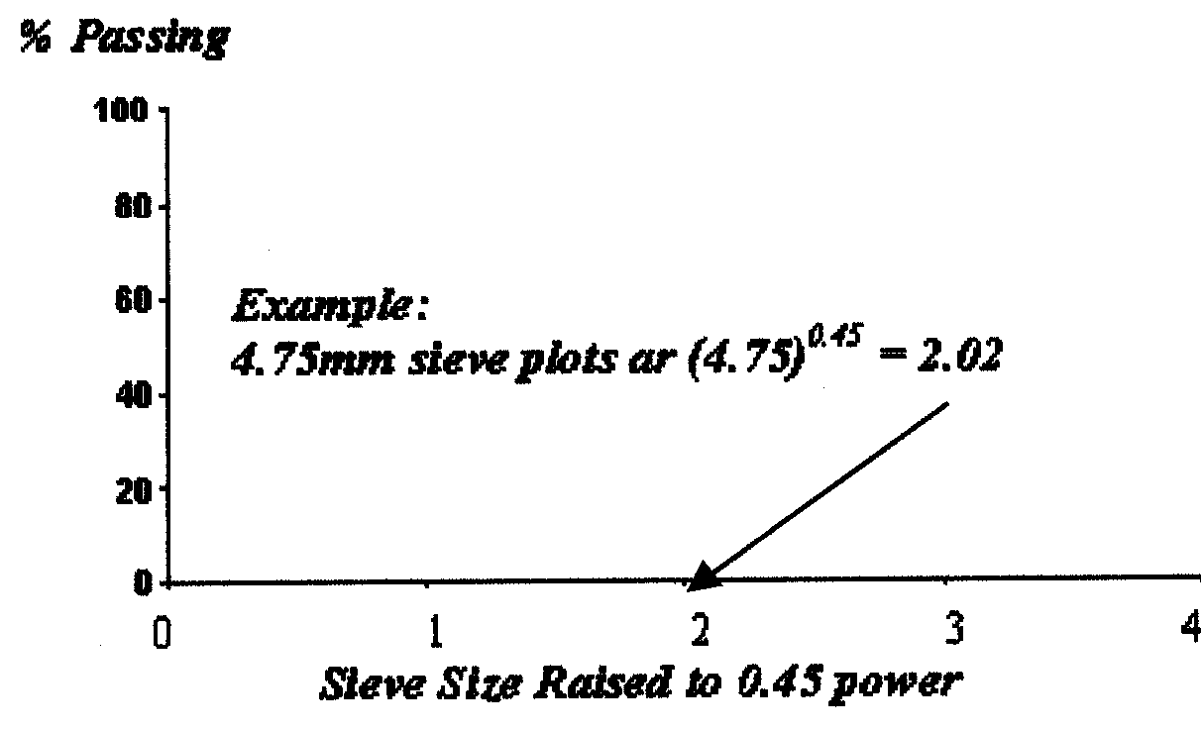
An important feature of this chart is the maximum density gradation. This gradation is plots as a straight line from the maximum aggregate size through the origin.
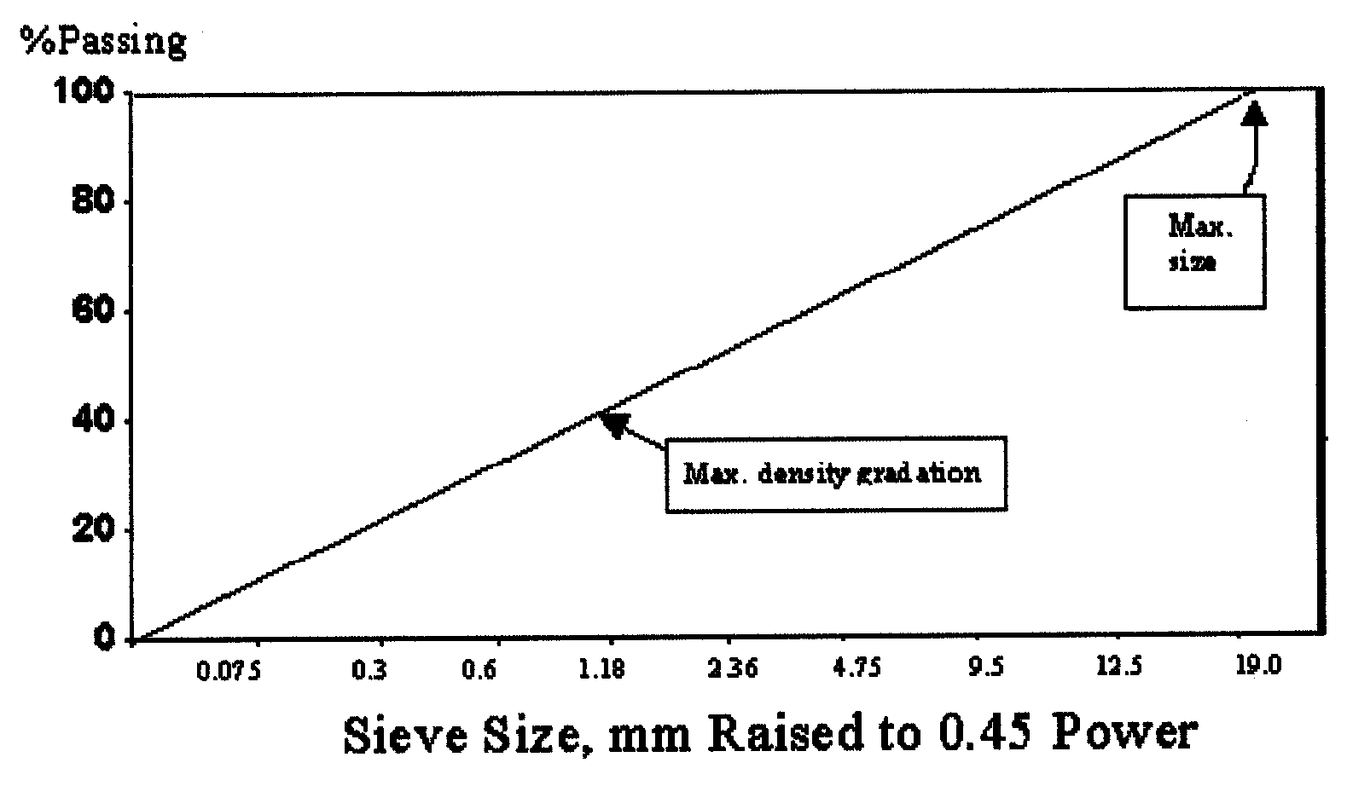
the restricted zone resides along the maximum density gradation between the intermediate size and 0.3 mm size. Gradations that pass though restricted zone has often been called "humped gradation" because of characteristics hump in the grading curve that passes through the restricted zone. A design aggregate structure that lies between the control points and avoids the restricted zone meets the requirements of Superpave with respect to gradation.
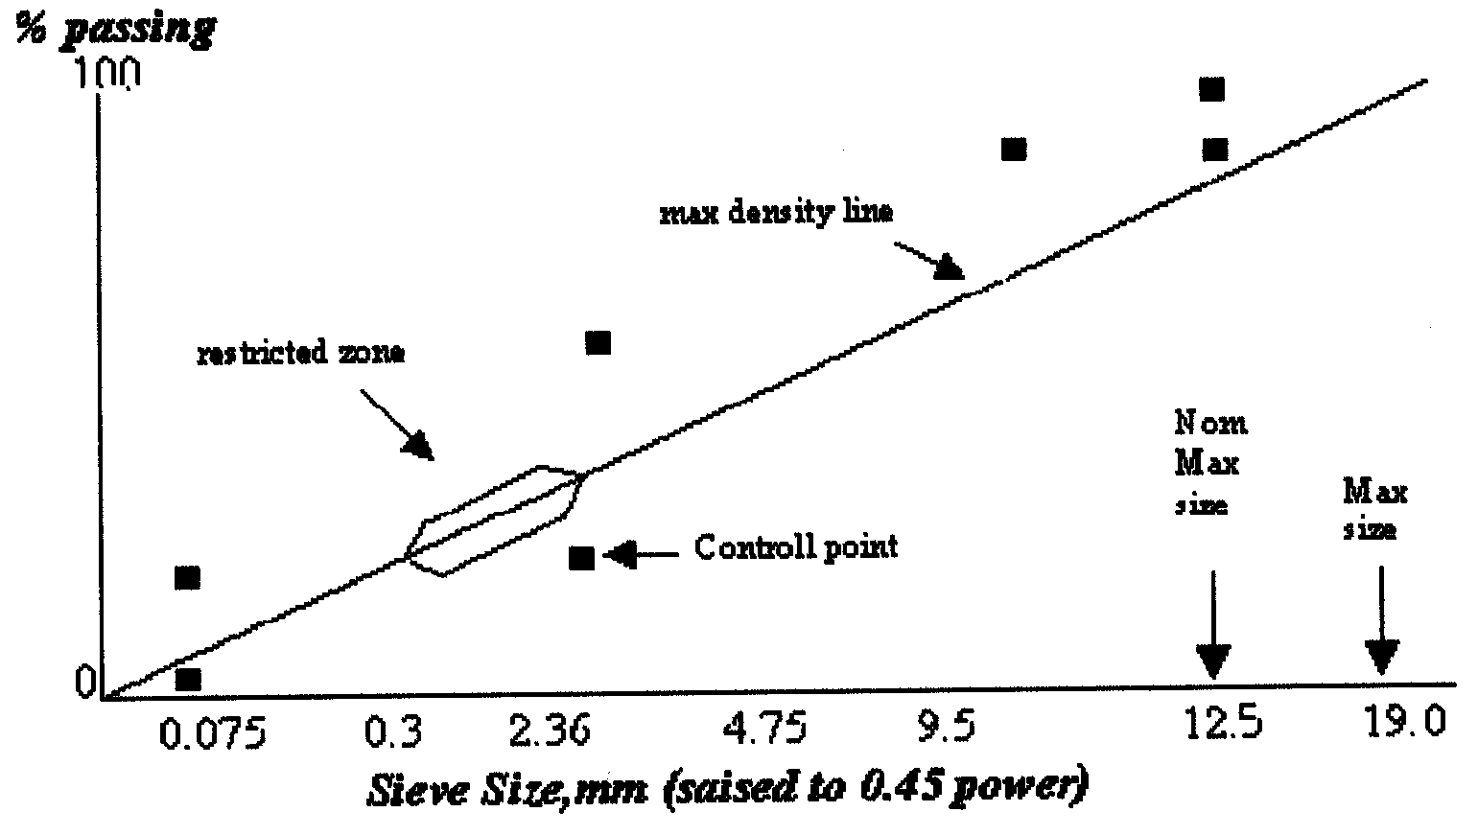
Superpave recommends, but does not require, mixtures to be graded below the restricted zone. It also recommends that as project traffic level increase, gradation move closer to the coarse (lower) control points. Furthermore, the Superpave gradation control requirements were not intended to be applied to special purpose mix types such as stone matrix asphalt or open graded mixture.
Several trial combinations of aggregates are to be evaluated to determine an appropriate aggregate structure, which is the combination of aggregates that exhibits suitable volumetric and identified properties. Once the blends are established, trial binder content is selected for each blend. The trial asphalt binder content is selected using an estimation procedure contained in Superpave or on the basis of the designer's experience.
Two specimen of each blend are batched and compacted in the Superpave gyratory compactor. In addition, two loose specimen of each trial blend are produced and used to measure maximum theoretical specific gravity. The volumetric densification characteristics of trial blend are analyzed and compared with "Superpave mix design criteria".

2 – Design aggregate structure (DAS) :
Refer to SP-2 and Appendix

3 – Design asphalt content (DAC) :
Refer to SP-2 and Appendix
4 – Water sensitivity evaluation :
Refer to SP-2 and Appendix

Appendix
Standard Test Method for SUPER PAVE MIX DESIGN PROCEDURE
AASHTO - TP4

PURPOSE: The purpose of the Superpave mix design procedure is to determine the design asphalt content for the asphalt mix that meets the criteria of Superpave.

Test Equipment
The primary device used in Superpave mix design is the Superpave gyratory compactor (SGC), The SGC is used to produce specimens for volumetric analysis and records data of specimen density throughout the test.

Additional Test Equipment

Ancillary test equipment required in the preparation of Superpave asphalt mixtures includes:
1. Ovens, thermostatically-controlled, for heating aggregates, asphalt, and equipment.
2. Mechanical Mixer: commercial bread dough mixer 10 liter (10 qt.) capacity or larger, equipped with two metal mixing bowls and two wire whips.
3. Flat-bottom metal pans for heating aggregates.
4. Round metal pans, approximately l0 liter (10-qt.) capacity, for mixing asphalt and aggregate.
5. Scoop for batching aggregates.
6. Containers: gill-type tins, beakers, or pouring pots, for heating asphalt.
7. Thermometers: armored, glass, or dial-type with metal stem, 10°C to 235°C, for determining temperature of aggregates, asphalt and asphalt mixtures.
8. Balances: 10-kg capacity, sensitive to 1 g, for weighing aggregates and asphalt; 10-kg capacity, sensitive to 0.1 g, for weighing compacted specimens.
9. Large Mixing Spoon or small trowel.
10. Large spatula.
11. Welders gloves for handling hot equipment.
12. Paint, markers, or crayons, for identifying test specimens.
13. Paper disks, 150 mm, for compaction.
14. Fans for cooling compacted specimens.
15. Computer or printer for data collection and recording.

Specimen Preparation

• Determine the mixing and compaction temperature using a plot of viscosity versus temperature.
• Select mixing and compaction temperature corresponding with binder viscosity of 0.17 ± 0.02 Pa.S and 0.28 ± 0.03 respectively.
• Specimen used for volumetric determination only, requires approximately 4500 grams of mixture, to arrive at a specimen 115 + 5 mm height.
• Specimen used for performance testing required approximately 5500 grams of mixture to fabricate a specimen that as 135 mm in height approximately.
• At least one loose sample should remain uncompacted to obtain a maximum theoretical specific gravity using AASHTO-T209.
• For performing moisture sensitivity test (AASHTO - T283). Test specimen are fabricated to a height of 95 mm which requires approximately 3500 grams of mixture.
• Place the pan containing the aggregate in an oven set approximately 15 °C higher than the mixing temperature. Two to four hours are required for the aggregates to reach the mixing temperature, heat all mixing implements.
• Heat the asphalt binder to the desired mixing temperature.
Preparation of Mixtures
• Place the hot mix bowl on a scale and zero the scale.
• Charge the mixing bowl with the heater aggregate.
• From a crater in the blended aggregate and weight the required asphalt in to the mixture to achieve the desired batch weight.
• Mix the asphalt and aggregate using a mechanical mixer until the aggregate is thoroughly coated.
• Place the mix in a flat shallow pan at an even thickness of 21-22 Kg/m² and place the pan in the forced draft oven at 135 °C. Short term aggregate the specimen for 4 hours.
Compaction of Volumetric Specimen
• The compactor is initiated by turning on the main power. The vertical pressure should be set at 600 kpa ( ±18 Kpa). The gyration counter should be zeroed and set to stop when the desired number of gyrations is achieved. Three gyration levels are of intrest:
  - design number of gyration (N_{des})
  - initial number of gyration (N_{ini})
  - maximum number of gyration (N_{max})
The range of values for N_{des}, N_{in}, N_{max} are shown :

Superpave Design Gyratory Compactive Efforts
Design ESAL  (Millions) | Average Design High Air Temperature
 | <39 ⁰C  N_{ini} N_{des} N_{max} |  |  | 39 – 40 ⁰C  N_{ini} N_{des} N_{max} |  |  | 41 – 42 ⁰C  N_{ini} N_{des} N_{max} |  |  | 43 – 44 ⁰C  N_{ini} N_{des} N_{max}
< 0.3  0.3 -1  1 – 3  3 – 10  10 – 30  30 – 100  >100 | 7  7  7  8  8  9  9 | 68  76  96  96  109  126  142 | 104  117  134  152  174  204  233 | 7  7  8  8  9  9  10 | 74  83  95  106  121  139  158 | 114  129  150  169  195  228  262 | 7  7  8  8  9  9  10 | 78  88  100  113  128  146  165 | 121  138  158  181  208  240  275 | 7  8  8  9  9  10  10 | 82  93  105  119  135  153  172 | 127  146  167  192  220  253  288

- Prepare the compaction while mixture specimen are short term aging. This includes verifying that the compaction pressure. The compaction angle and number of gyration are set to their proper values and setting the desired number of gyrations N_{max}, ensure that the data acquisition device is functioning.
• Approximately 45 - 60 minutes before compaction of the first specimen place the compaction mold and base/top plates in oven set at the compaction temperature.
• After four hours of short term aging remove the mixture from the oven. If the compaction temperature is greater than 135 °C, place the mixture in another oven for no longer than 30 minutes until it reaches the desired compaction temperature. If the compaction temperature is less than 135 °C place the mixture at room temperature until the compaction temperature is reached.
• Remove the mold and base plate from the oven. Place the base plates in the mold and place a paper disk on top of the base plate.
• Charge the mold with the aged asphalt mixture in a single lift. The top of the uncompacted specimen should be slightly rounded.
• Place a paper disk on top of the mixture.
• The mold is placed in the compactor and centered under the room, then start the gyration system.
• When N_{max} has been reached the compactor automatically slopes, angle and pressure are released.
• Remove the mold containing compacted specimen.
• Cool the mold for a suitable period for 5 to 10 minutes will facilitate specimen removal without undue distortion.
• Extrude the specimen from mold.
• Remove the paper disk from top and bottom of the specimen and allow the specimen to cool undisturbed.
• Identify specimen with a suitable marker.

Data Analysis and Presentation
Superpave gyratory compaction data is analyzed by computing the estimated bulk specific gravity, corrected bulk specific gravity, and corrected percentage of maximum theoretical specific gravity for each desired gyration. During compaction, the height is measured and recorded after each gyration. G_{mb} of the compacted specimen and G_{mm} of the loose mixture are measured. An estimate of G_{mb} at any value of gyration is made by dividing the mass of the mixture by the volume of the compaction mold:
G_{mb} (estimated) =
where,
G_{mb}(estimated) = estimated bulk specific gravity of specimen during compaction
W_{m} = mass of specimen, grams
γ_{w} = density of water = 1 g/cm³
V_{mx} = volume of compaction mold (cm³) calculated using the equation:
V_{mx} = * 0.001 cm³ / mm³ = 17.6715 h_{x}
where,
d = diameter of mold (150 mm), and
h_{x} = height of specimen in mold during compaction (mm).
π = 3.1416
This calculation assumes that the specimen is a smooth-sided cylinder, which it is not. Surface irregularities cause the volume of the specimen to be slightly less than the volume of a smooth-sided cylinder. Therefore, the final estimated G_{mb} at N_{max} is different than the measured G_{mb} at N_{max}. Therefore, the estimated G_{mb} is corrected by a ratio of the measured to estimated bulk specific gravity:
C =
where,
C = correction factor,
G_{mb}(measured) = measured bulk specific gravity after N_{max},
G_{mb}(estimated) -estimated bulk specific gravity at N_{max}.
The estimated G_{mb} at any other gyration level is then determined using:
G_{mb} (corrected) = C x G_{mb}(estimated)
where,
G_{mb}(corrected) = corrected bulk specific gravity of the specimen at any gyration.
C = correction factor, and
G_{mb}(estimated) = estimated bulk specific gravity at any gyration.
Percent G_{mm} at any gyration level is then calculated as the ratio of G_{mb} (corrected) to G_{mm} (measured), and the average percent G_{mm} values for the two companion specimens are calculated.

Using the N_{max}, N_{des}, and N_{ini} gyrations levels previously determined from design traffic level and the design high air temperature for the particular project (Table 5.1), Superpave volumetric mix design criteria (VMA, VFA, and dust ratio) are established on a four percent air void content at N_{des}. Superpave mix design also specifies criteria for the mixture density at N_{ini}, N_{des}, and N_{max}.

The percentage of air voids at N_{des} is determined from the equation:
V_{a} = 100 -%G_{mm}@ N_{des}
Where,
V_{a} = air voids @ N_{des}, percent of total volume
%G_{mm}@ N_{des} = maximum theoretical specific gravity @ N_{des}, percent

The percent voids in the mineral aggregate is calculated using:
%VMA = 100 -
where,
VMA = voids in mineral aggregate, percent of bulk volume
%G_{mm}@ N_{des} = maximum theoretical specific gravity @ N_{des}, percent
G_{mm} = maximum theoretical specific gravity
G_{sb} = bulk specific gravity of total aggregate
P_{s} = aggregate content, cm³/cm³, by total mass of mixture
If the percentage of air voids is equal to four percent, then this data is compared to the volumetric criteria and an analysis of this blend completed. However, if the air void content at N_{des} varies from four percent (and this will typically be the case), an estimated design asphalt content to achieve 4 percent air voids at N_{des} is determined, and the estimated design properties at this estimated design asphalt content are calculated. The estimated asphalt content at N_{des} = 4% air voids is calculated using this equation:
P_{b,estimated} = P_{bi} – (0.4 x (4-V_{a})
where
P_{b,estimated} = estimated asphalt content, percent by mass of mixture
F_{bi} = initial (trial) asphalt content, percent by mass of mixture
V_{a} = percent air voids at N_{des} (trial)
The volumetrics (VMA and VFA) at N_{des} and mixture density at N_{ini} and N_{max} are then estimated at this asphalt binder content using the equations that follow.
For VMA:
%VMA_{estimated} = % VMA_{initial} + C * (4 – V_{a})
where:
%VMA_{initial} = %VMA from trial asphalt binder content
C = constant = 0.1 if V_{a} is less than 4.0 percent
= 0.2 if V_{a} is greater than 4.0 percent
Specified minimum values for VMA at the design air void content of four percent are a function of nominal maximum aggregate size and are given in Table 1.
Table 1. VMA Criteria.
Nominal Maximum Aggregate Size | Minimum VMA, percent
9.5 mm | 15.0
12.5 mm | 14.0
19.0 mm | 13.0
25.0 mm | 12.0
37.5 mm | 11.0

For VFA:
%VFA_{estimated} = 100 *
The acceptable range of design VFA at four percent air voids as a function of traffic level is shown in Table 2.

Table 2. VFA Criteria
Traffic, million ESALs | Design VFA, percent
< 0.3 | 70 – 80
< 1 | 65 – 78
< 3 | 65 – 78
< 10 | 65 – 75
< 30 | 65 – 75
< 100 | 65 – 75
≥ 100 | 65 – 75

For %G_{mm} at N_{ini}:
%G_{mm} _{estimated} @ N_{ini} = %G_{mm} _{trial} @ N_{ini} -(4.0 – V_{a})
The maximum allowable mixture density at N_{ini} is 89 percent.
For %G_{mm} at N_{max}:
%G_{mm estimated} @ N_{max} = %G_{mm tria1}@ N_{max} -(4.0 – V_{a})
The maximum allowable mixture density at N_{max} is 98 percent.
Finally, there is a requirement for the dust proportion. It is calculated as the percent by mass of the material passing the 0.075 mm sieve (by wet sieve analysis) divided by the effective asphalt binder content (expressed as percent by mass of mix). The effective asphalt binder content is calculated using:
P_{be} = - (P_{s} * G_{b}) * + P_{b, estimated}
where
P_{be} = effective asphalt content, percent by total mass of mixture
P_{s} = aggregate content, percent by total mass of mixture
G_{b} = specific gravity of asphalt.
G_{se} = effective specific gravity of aggregate
G_{sb} = bulk specific gravity of aggregate
Pb = asphalt content, percent by total mass of mixture
Dust Proportion is calculated using:
DP =
Where
P_{0.075} = aggregate content passing the 0.075 mm sieve, percent by mass of aggregate
P_{be} = effective asphalt content, percent by total mass of mixture
An acceptable dust proportion ranges from 0.6 to 1.2 for all mixtures.
After establishing all the estimated mixture properties, the designer can look at the trial blends and decide if one or more are acceptable, or if further trial blends need evaluation.
Selection of the Design Asphalt Binder Content
After the selecting the binder grade from the environmental and weather station data:
• Evaluate an initial design asphalt trial content for each gradation.
• The trial asphalt binder content is determined for each trial blend by estimating the effective specific gravity of the blend and using the calculation.
• The effective specific gravity (G_{se}) of the blend is estimated by:
G_{se} = G_{sb} + 0.8 * (G_{sa} – G_{sb})
G_{se} = effective specific gravity of blend (combined aggregate)
G_{sb} = bulk specific gravity of blend (combined aggregate).
• The volume of asphalt binder (V_{ba}) absorbed in to aggregate is estimated using this equation:
V_{ba} =
V_{ba} = volume of absorbed binder, cm³/cm³ of mix.
P_{b} = percent of binder (assumed 0.05)
Ps = percent of aggregate (assumed 0.05)
G_{b} = specific gravity of binder (assumed 1.02)
• The volume of the effective binder (Vbe can be determined from this equation:
V_{be} = 0.081 - 0.02931 * [in (S_{n})] = cm³/cm³ of mix.
where
S_{n} = the nominal maximum sieve size of the aggregate blend (in inches).
• Finally, the initial trial asphalt binder (P_{bi}) is calculated from this equation:
P_{bi} =
where
P_{bi} = percent (by weight of mix) of binder.
W_{s} = weight of aggregate, grams.

