Tutorial: Network Topology
CASE STUDY 1:
A small, independent, business/home/life insurance company consisting of an owner, a business manager, an administrator, and four agents decides to implement a network. The company occupies half of a small building in an office park. Their volume of business had been stable for the past three years, but recently it has been increasing. To handle the increased business volume, two new agents will be hired.
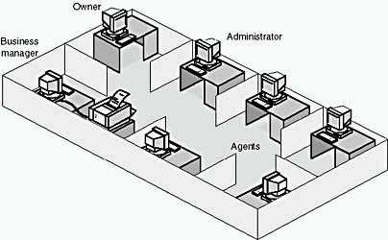
Everyone in the company has a computer, but the business manager has the only printer. These computers are not connected by any form of networking. When agents need to print a document, they must first copy the file to a floppy disk, then carry it to the business manager's computer, where they are finally able to print it. Similarly, when staff members want to share data, the only means available is to copy the data on one computer to a floppy disk and insert the disk in another computer.
Recently, problems have arisen. The business manager is spending too much time printing other people's documents; and it is frequently unclear which copy of a given document is the current and authoritative version.
Your task is to design a network for this company.
To clarify the task of choosing a solution, you ask some questions. Circle the most appropriate answers to the following questions:
- Which type of network would you suggest for this company?
  - Peer-to-peer
  - Server-based
- Which network topology would be most appropriate in this situation?
    - Bus - Ring
    - Star - Mesh
    - Star bus - Star ring
CASE STUDY 2:
A small company with three departments recently began networking and has installed peer-to-peer networks in each department. The peer-to-peer networks are not connected to each other. A user in one department must make a diskette of the information to be loaded on the next network. Four employees in one department are working on a project. Each person has a different set of responsibilities, and each produces documentation for a different part of the project. Employees have each made the hard drive on their own computers available to everyone else on the project.
As the project grows, each user produces more documents, and questions arise about who has which document and which employee last revised a given document. Also, employees outside the department who have an interest in the project are asking to see some of the completed material.
- Why are problems arising concerning who has which document? Suggest at least one reason.
- What one change could you make that would give you centralized control of the access to these documents?
- Describe one change that your solution will bring to the users' operating environment.

