Tutorial #7

Question#1: What is the output of the following programs?

Private Sub btnDisplay_Click(...) Handles btnDisplay.Click
Dim firstName As String = ""
Dim lastName As String = ""
Dim salary, newSalary As Double salary = 0
textBox1.Text="First Name: " & firstName & " Last Name: " & lastName & " Salary =" & salary

InputData(firstName, lastName, salary)

textBox3.Text="First Name: " & firstName & " Last Name: " & lastName & " Salary =" & salary

newSalary = RaisedSalary(salary)

textBox5.Text=" salary =" & salary & ", New Salary =" & newSalary

End Sub

Sub InputData(ByRef firstName As String, ByVal lastName As String, ByRef salary As Double)
firstName = txtFirstName.Text
lastName = txtLastName.Text
salary = CDbl(txtCurrentSalary.Text)

textBox2.Text="First Name:" & firstName & "Last Name:" & lastName & "Salary =" & salary

End Sub

Function RaisedSalary(ByVal salary As Double) As Double
If salary <= 40000 Then salary= 1.05 * salary Else
salary = salary + 2000 + 0.02 * (salary - 40000) End If
textBox4.Text=" salary =" & salary
Return salary
End Function

Input:

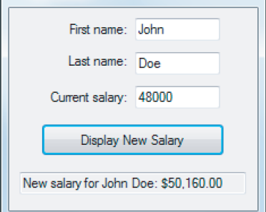30000

textBox1.Text
textBox2.Text
textBox3.Text
textBox4.Text
textBox5.Text

Question#2: Extract errors from the following codes & then obtain weather they are Syntax
Error or Run time Error?

a)
1 Private Sub CalculateArea(Byval Length As Double) As Double
2 Return Length ^ 2
3 End Sub

Line# | Error Description | Error Type (Syntax or Runtime) | Correction

b)
1 Private Sub btnCalculate_Click(...) Handles btnCalculate.Click
2
3 Dim weight As String = txtWeight.Text
4 Dim height As String = txtHeight.Text
5 Dim result As Double
6
7 result = BMI(weight, height)
8 End Sub
9
10 Function BMI(ByVal w As Double, ByVal h As Double) As Double
11 Dim r As String
12
14 r = "The result equals to " & ((703 * w) / (h ^ 2))
15 Return r
16 End Function

Line# | Error Description | Error Type (Syntax or Runtime) | Correction

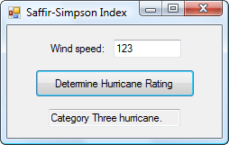

Question #3: Convert the following program into three procedures (functions or subroutine) (one for reading input – two for processing input – three for displaying output)

Original Code

Private Sub btnDetermine_Click(...) Handles btnDetermine.Click

Dim speed As Double = txtSpeed.Text
Dim outText As String = Nothing

If speed < 74 Then
outText= "Not a hurricane." ElseIf speed <= 95 Then
outText = "Category One hurricane."
ElseIf speed <= 110 Then
outText = "Category Two hurricane." ElseIf speed <= 130 Then
outText = "Category Three hurricane."
ElseIf speed <= 155 Then
outText = "Category Four hurricane." Else
outText = "Category Five hurricane." End If

txtOutcome.Text = outText

End Sub

Code after breaking it to procedures:

