Tutorial # 6
Question#1: write the code for this form:
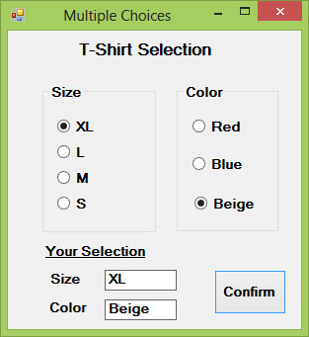

Question#2: what the output from the following code (design the form)?
Private Sub Button1_Click(sender As Object, e As EventArgs) _
Handles Button1.Click
Dim str As String
str = " "
If CheckBox1.Checked = True Then
str &= CheckBox1.Text
str &= " "
End If
If CheckBox2.Checked = True Then
str &= CheckBox2.Text
str &= " "
End If
If CheckBox3.Checked = True Then
str &= CheckBox3.Text
str &= " "
End If
If CheckBox4.Checked = True Then
str &= TextBox1.Text
str &= " "
End If
If str <> Nothing Then
MsgBox(str + vbLf + "Thank you")
End If
End Sub
Private Sub CheckBox4_CheckedChanged(sender As Object, _
e As EventArgs) Handles CheckBox4.CheckedChanged
Label1.Visible = True
TextBox1.Visible = True
End Sub

