Tutorial set #4
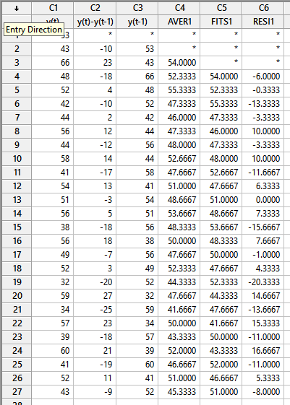
Question 1:

1-
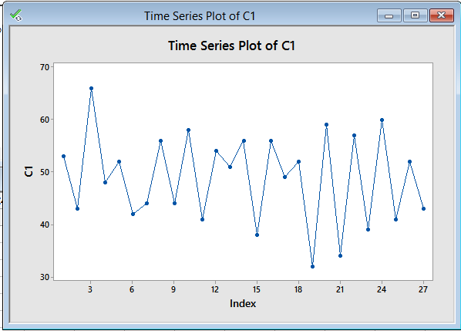

From the figure, it appears that the data are stationary in the mean, as there do not seem to be a clear trend component in the data. Also, the variance seems to be constant over the time, hence, the series seem to be stationary.

2-
As we see from the plot of the series, most of the time there exist a value above the mean followed by a value beneath the mean and so on. Thus, we expect that the value of $ρ_{1}$ to be negative, however its exact value is difficult to guess from the figure, but we don’t expect that it will be a high value (i.e. near to one) because the fluctuations are not the same across the series.
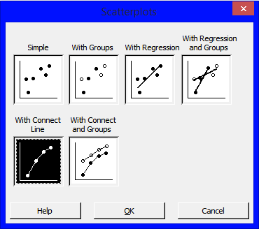
3-
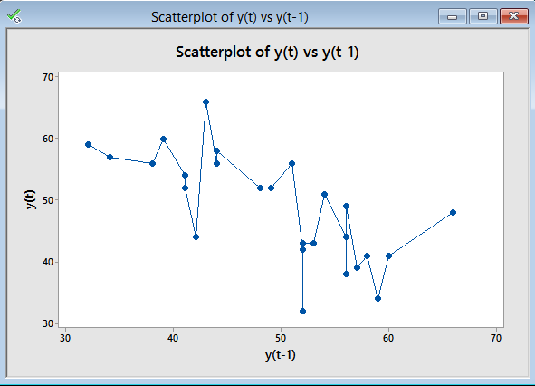
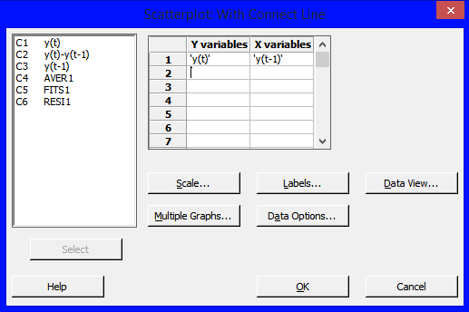
As we see from the plot, the behavior we anticipated for the relation between any two observations that are one time apart is clear. As we notice the negative correlation between the observations, as the regression line between $y_{t}$ and $y_{t-1}$ is decreasing. We can estimate visually the value of $ρ_{1}$ (which is the slope of the line) maybe between -0.6 and -0.7.

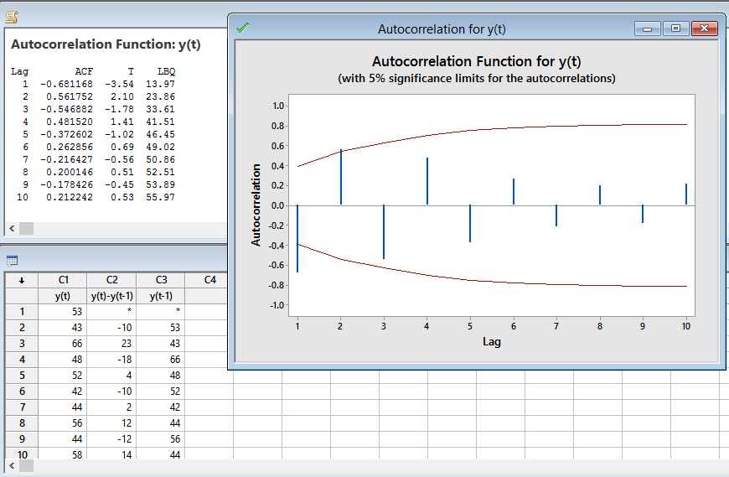
4-

Where we got the SACF for the data for any time lags, we notice here that ${\hat{ρ}}_{1}=r_{1}=-0.68117$ , we also notice that the autocorrelation decrease as time lag increase (this is a characteristic of the stationary processes). Notice also that all values of $r_{k}$ after the first time lag lie within the 95% C.I , we thus can test the hypothesis that all autocorrelation coefficient after time lag 1 are not different from zero.
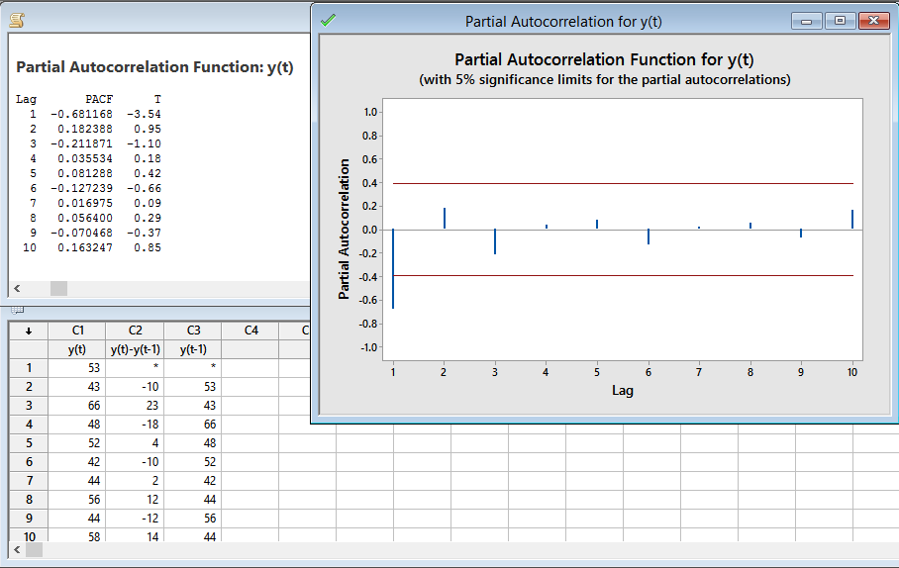
5-

We notice from the figure that only one value of $r_{kk}$ is outside the 95% C.I., whereas all the rest of the values are within the 95% C.I. which means that they are not significantly different from zero. Notice also that $r_{1}=r_{11}=-0.68117$ which is always true.
Question 2:
1-
The mean of the series looks constant over time, the same could be said about the variance. Which indicate that the series is stationary. Also, notice that the series exhibit a seasonal pattern, where the average temperatures decrease for months 6,7 and 8 every year. Whereas the temperatures increase gradually for the rest of the year. So, the model we use for the data should incorporate a seasonal component, and must estimate its coefficients and test their significance.
2-
It is clear that the series exhibit an increasing trend component and thus the series is not stationary. We can deal with the problem of non-stationarity in the mean by applying the difference operator $∇$, so we take the first order difference and inspect the resulting series to to see if it succeeded in turning it to a stationary series or not, otherwise we can take the second difference. We also notice that the variance of the series increases with time, hence it is not stationary in variance as well. We can use for example the logarithmic transformation or any other transformation in the Box-Cox family of transformations. But be aware that if there is a need to apply both transformations for the data, then logarithmic transformation must be applied before the differences.
3-
The series seems to be stationary in the mean, as it does not change over time. There is a slight indication of non-stationarity in the variance, we can confirm this by applying the logarithmic transformation to the data and study the resulting series.
4-
It is clear that the series exhibit an increasing trend component and thus the series is not stationary. We can deal with the problem of non-stationarity in the mean by applying the difference operator $∇$, so we take the first order difference and inspect the resulting series to to see if it succeeded in turning it to a stationary series or not, otherwise we can take the second difference. We do not notice any problem of the variance as it seems constant as time increase.

Question 3:
In the general linear process (GLP) , $Y_{t}=μ_{Y}+\sum_{j=0}^{∞}{ψ_{j}ε_{t-j} }$, we used the following $ψ_{j}$ weights:
- $ψ_{j}=ϕ^{j}$ for j=1,2,…, where $\left|ϕ\right|<1$. What is the form of the resulting process, and derive its autocorrelation function.

$Y_{t}=μ_{Y}+\sum_{j=0}^{∞}{ψ_{j}ε_{t-j} }$
$=μ_{Y}+\sum_{j=0}^{∞}{ϕ^{j}}ε_{t-j}$
$$Y_{t}-μ_{Y}={ε_{t}+ϕ ε}_{t-1}+ϕ^{2}ε_{t-2}+ϕ^{3}ε_{t-3}+…$$
${=ε}_{t}+ϕ \left[{ε_{t-1}+ϕ ε}_{t-2}+ϕ^{2}ε_{t-3}+…\right]$
$=ε_{t}+ϕ \left[Y_{t-1}-μ_{Y}\right]$
Note: This process is called Autoregressive process of order one, since it is a regression of process at time $t$ on its value at time $t-1$ .
The ACF:
Taking the variance of both sides of the general linear process:
$${var(Y}_{t})=γ_{0}=var\left(\sum_{j=0}^{∞}{ψ_{j}ε_{t-j} }\right)=σ^{2}\sum_{j=0}^{∞}{ψ_{j}^{2}}$$
Also, finding the autocvariance for the process:
$${cov(Y}_{t}, Y_{t-k})=γ_{k}=cov\left(\sum_{j=0}^{∞}{ψ_{j}ε_{t-j} }, \sum_{j=0}^{∞}{ψ_{j }}ε_{t-k-j}\right)$$
$$=cov\left(\sum_{i=0}^{k-1}{ψ_{i}ε_{t-i} }+\sum_{i=k}^{∞}{ψ_{i}ε_{t-i} }, \sum_{j=0}^{∞}{ψ_{j }}ε_{t-k-j}\right)$$
And to let the summation in the term $\sum_{i=k}^{∞}{ψ_{i}ε_{t-i} }$ to start from zero, we use the index transformation: : $$let j=i-k ⇒i=j+k$$
Then,
$${cov(Y}_{t}, Y_{t-k})=cov\left(\sum_{i=0}^{k-1}{ψ_{i}ε_{t-i} }+\sum_{j=0}^{∞}{ψ_{j+k}ε_{t-\left(j+k\right)} }, \sum_{j=0}^{∞}{ψ_{j }}ε_{t-k-j}\right) =cov\left(\sum_{j=0}^{∞}{ψ_{j+k}{ ε}_{t-k-j} }, \sum_{j=0}^{∞}{ψ_{j }}ε_{t-k-j}\right)$$
$$=σ^{2}\sum_{j=0}^{∞}{ψ_{j }ψ_{j+k}}$$

And hence the ACF for the G.L.P. has the form:
$$\boxed{ρ_{k}=\frac{\sum_{j=0}^{∞}{ψ_{j }ψ_{j+k}}}{\sum_{j=0}^{∞}{ψ_{j}^{2}}}}$$
Now, substituting for $ψ_{j}=ϕ^{j}$, we get:
$ρ_{k}=\frac{\sum_{j=0}^{∞}{ϕ^{j}ϕ^{j+k}}}{\sum_{j=0}^{∞}{ϕ^{2j}}}=\frac{ϕ^{k}\sum_{j=0}^{∞}{ϕ^{2j}}}{\sum_{j=0}^{∞}{ϕ^{2j}}}=ϕ^{k} , k=0,1,2,..$
Thus, we deduce that the resulting process is an AR(1) process (a special case of the GLP), and it has the ability to model data that has the property of autocorrelation that decline in an exponential fashion (for $0<ϕ<1$), or in a declining sine wave fashion if $-1<ϕ<0$. Try using different values for $ϕ$.
- $ψ_{0}=1,ψ_{1}=-θ_{}$, $ψ_{j}=0,$ for $j=2,3,…$, where, $\left|θ\right|<1$. What is the form of the resulting process, and derive its autocorrelation function.
$$Y_{t}-μ_{Y}=\sum_{j=0}^{∞}{ψ_{j}ε_{t-j} }$$
$=(ε_{t}-θε_{t-1}+0 × ε_{t-2}+0 × ε_{t-3}+…)$

${∴Y}_{t}-μ_{Y}=ε_{t}-θε_{t-1}$
Note: This process is called a moving average of order 1, and it relates the process at time t with the errors (or shocks) at time t and time t-1.
The ACF:
Substituting for the value $ψ_{0}=1,$ $ψ_{1}={-θ}_{}$ and the rest of the weights $ψ_{j}=0, j>1$ in the general form of the autocorrelation function of the GLP, we get:
$$ρ_{k}=\frac{\sum_{j=0}^{∞}{ψ_{j }ψ_{j+k}}}{\sum_{j=0}^{∞}{ψ_{j}^{2}}}=\frac{ψ_{0 }ψ_{k}+ψ_{1 }ψ_{1+k}+ψ_{2 }ψ_{2+k}+…}{ψ_{0}^{2}+ψ_{1}^{2}+ψ_{2}^{2}+…}=\frac{ψ_{k}+-θψ_{1+k}}{1+θ_{}^{2}}$$
For k=1:
$${∴ρ}_{1}=\frac{-θ}{1+θ^{2}}$$
Note that using k=2, then all the terms in the numerator equals zero, this also true for any value $k≥2$. So, we note that the MA(1) process is a special case of the GLP, and it has the ability of modeling data that are correlated at one time lag only, and are uncorrelated for data that are further apart.

